Experiment: 1 (a)
Aim: Create a web application to demonstrate Servlet using student registration form.

Application File Structure:

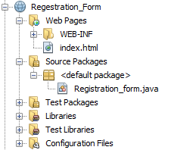

Source code:
index.html
<!DOCTYPE html>
<html lang="en">
<head>
<meta charset="UTF-8">
<meta http-equiv="X-UA-Compatible" content="IE=edge">
<meta name="viewport" content="width=device-width, initial-scale=1.0">
<title>Registration Form</title>
<style>
.div{
width:400px;
position:absolute;
top:50%;
left:50%;
transform: translate(-50%,-50%);
box-shadow: 20px 20px 50px rgba(0,0,0,0.5) ;
background:rgba(255,255,255,0.2);
padding : 30px;

background: rgba(255, 255, 255, 0.16);
border-radius: 16px;
box-shadow: 0 4px 30px rgba(0, 0, 0, 0.1);
backdrop-filter: blur(5.6px);
-webkit-backdrop-filter: blur(5.6px);
border: 1px solid rgba(255, 255, 255, 0.02);
}
body{
background: linear-gradient(#0077ff,rgb(0, 255, 157));
height: 98vh;
}
.in{
width:93%;
background:none;
border:none;
outline: none;
border-bottom: 2px solid rgb(12, 36, 255);
cursor:pointer;
padding:5px;
margin:5px;
font-size:18px;
align-items: center;
}
.bt{
width:95%;
background:none;
border:2px solid rgb(0, 17, 255);
cursor:pointer;
padding:5px;
margin:5px;
font-size:18px;
align-items:center;
}
.bt:hover{
background-color:yellow;
}
.c{
width: 20px;
height:20px;
}

.lables{
font-family: 'Franklin Gothic Medium', 'Arial Narrow', Arial, sans-serif;
font-size: 20px;
}
</style>
</head>
<body>
<div class="div">
<form action="Registration_form">
<table>
<tr>
<td class="lables">Name</td>
<td><input type="text" class="in" name="name"></td>
</tr>
<tr>
<td class="lables">Reg no.</td>
<td><input type="text" class="in" name="reg_no"></td>
</tr>
<tr>
<td class="lables"> Academic Year</td>
<td><input list="year" class="in" name="year"></td>

<datalist id="year">
<option value="2015-2016">
<option value="2016-2017">
<option value="2017-2018">
<option value="2018-2019">
<option value="2019-2020">
<option value="2020-2021">

</datalist>
</tr>
<tr>
<td class="lables">Branch</td>
<td><input type="text" list="Branch" class="in" name="branch"></td>

<datalist id="Branch">
<option value="CSE">
<option value="IT">
<option value="ECE">
<option value="EEE">
<option value="Civil">
<option value="Mechanical">
<option value="E&I">
<option value="Data Science">
<option value="Cyber Security">
</datalist>

</tr>
<tr>
<td class="lables">Year Of Study</td>
<td><input list="yos" name="year_of_study" class="in"></td>
<datalist id="yos">
<option value="I Year ">
<option value="II Year">
<option value="III Year">
<option value="IV Year">
</datalist>
</tr>
<tr>
<td class="lables">Course</td>
<td><input list="course" name="course" class="in"></td>
<datalist id="course">
<option value="B.TECH."></option>
<option value="M.TECH."></option>
<option value="M.SC."></option>
<option value="MCA"></option>
<option value="DIPLOMA"></option>
</datalist>
</tr>

<tr>
<td class="lables">Languages</td>
<td>
<input type="checkbox" class="c" name="Languages" value="python">
<label for="python" class="lables"> Pyton&nbsp;</label>

<input type="checkbox" class="c" name="Languages" value="c">
<label for="c" class="lables">C</label><br>
<input type="checkbox" class="c" name="Languages" value="java">
<label for="java" class="lables"> Java &nbsp;&nbsp;</label>
<input type="checkbox" class="c" name="Languages" value="c++">
<label for="c++" class="lables">C++</label>
</td>
</tr>
<tr>
<td><input type="submit" class="bt" value="Submit"></td>
<td><input type="reset" class="bt" value="Reset"></td>
</tr>
</table>

</form>
</div>
</body>
</html>
Output:

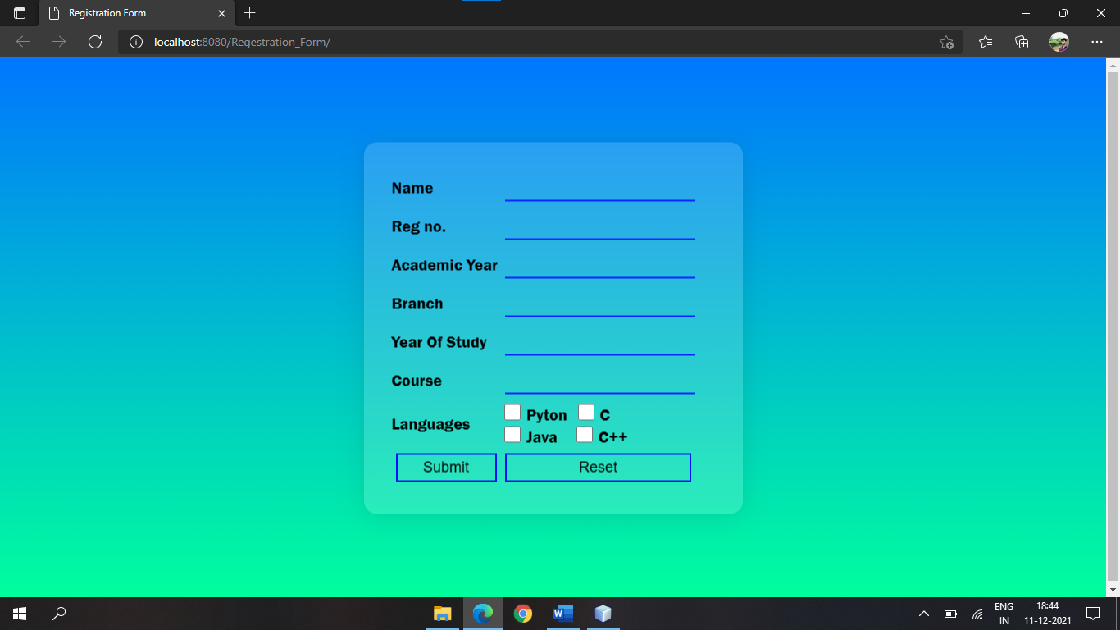

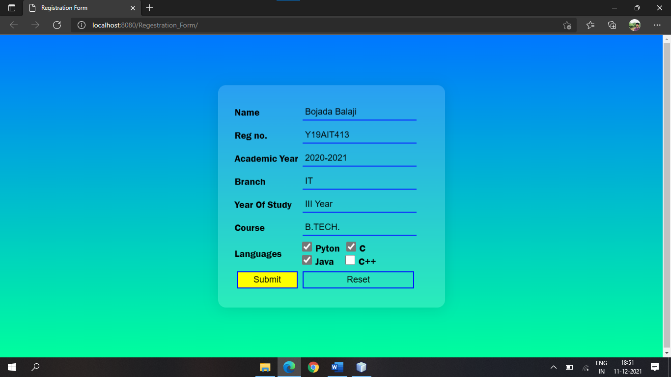

Registration_form.java
import java.io.IOException;
import java.io.PrintWriter;
import java.util.Enumeration;
import javax.servlet.ServletException;
import javax.servlet.http.HttpServlet;
import javax.servlet.http.HttpServletRequest;
import javax.servlet.http.HttpServletResponse;

public class Registration_form extends HttpServlet {
@Override
protected void doGet(HttpServletRequest request, HttpServletResponse response)
throws ServletException, IOException {

response.setContentType("text/html;charset=UTF-8");
try (PrintWriter out = response.getWriter()) {
out.println("<!DOCTYPE html>");
out.println("<html>");
out.println("<head>");
out.println("<title>Servlet Registration_form</title>");
out.println("</head>");
out.println("<body>");
out.println("<h1>Student Detials</h1>");
out.println("<h3>");

Enumeration names=request.getParameterNames();
while(names.hasMoreElements()){
String name=(String)names.nextElement();
String[] values=request.getParameterValues(name);
out.println("<br>"+name+" : ");
for(String v:values){
out.println(v);
}
}

out.println("</h3>");
out.println("</body>");
out.println("</html>");
}
}
}

Output:

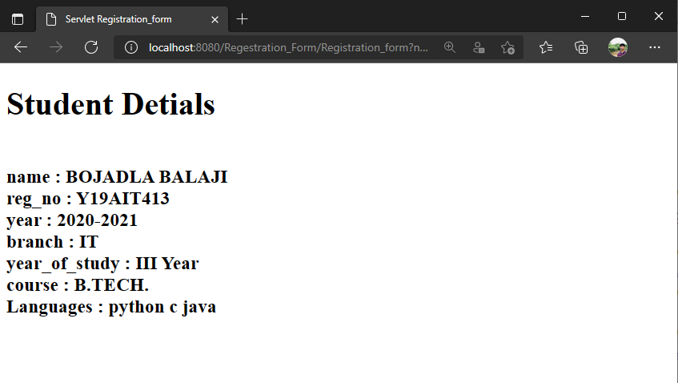

Experiment: 1 (b)
Aim: Create a web application to demonstrate Servlet using units converter.
Application File Structure:
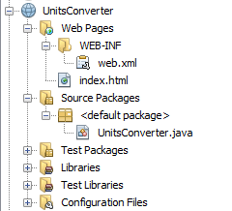

Source code:
index.html
<!DOCTYPE html>
<html>
<head>
<title>Units Converter</title>
<meta charset="UTF-8">
<meta name="viewport" content="width=device-width, initial-scale=1.0">
<style>
body{
background: linear-gradient(#f00,#f0f);
height: 98vh;
}
#h{
color:red;
}
#btn{
width:95%;
background:none;
border:2px solid red;
cursor:pointer;
padding:5px;
margin:5px;
font-size:18px;
align:center;
}
.in{
width:93%;
background:none;
border:none;
outline: none;
border-bottom: 2px solid red;
cursor:pointer;
padding:5px;
margin:5px;
font-size:18px;
align: center;
}
.in2{
width:40%;
background:none;
border:none;
outline: none;
border-bottom: 2px solid red;
cursor:pointer;
padding:5px;
margin:5px;
font-size:18px;
align: center;
}
#btn:hover{
background-color:yellow;
}
.login-box{
width:300px;
position:absolute;
top:50%;
left:50%;
transform: translate(-50%,-50%);
box-shadow: 20px 20px 50px rgba(0,0,0,0.5) ;
background:rgba(255,255,255,0.2);
padding : 30px;
}
input::placeholder {
color: red;
opacity: 1;
}
.hh{
float:left;
border-bottom: 2px solid red;
}
#btn{
margin:10px;
}
#arr{
font-size:32px;
}
</style>
</head>
<body bgcolor="pink">
<div class="login-box">
<h1 id="hh" >Units Converter</h1>
<form action="UnitsConverter">
<input class="in" type="text" name="input" placeholder="Enter Value"/><br>
<select class="in2" name="from_units">
<option value="cm">cm</option>
<option value="m">m</option>
<option value="inches">inches</option>
<option value="km">km</option>
<option value="feet">feet</option>
</select>
<span id="arr"><b>&#8594;</b></span>
<select class="in2" name="to_units">
<option value="m">m</option>
<option value="cm">cm</option>
<option value="inches">inches</option>
<option value="km">km</option>
<option value="feet">feet</option>
</select>
<br><input id="btn" type="submit" value="submit"/>
</form>
</div>
</body>
</html>
Output:

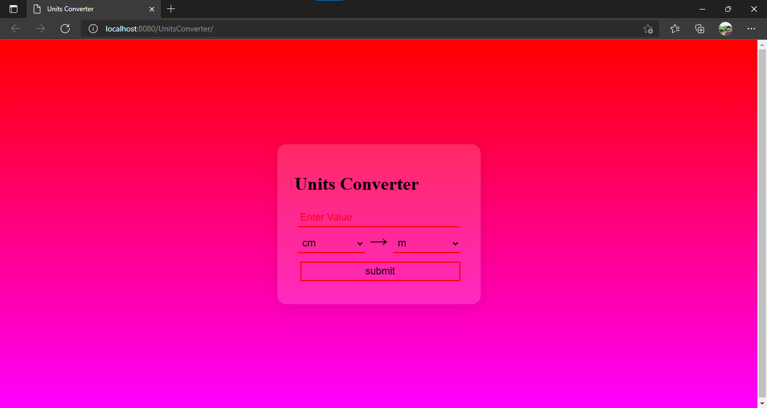

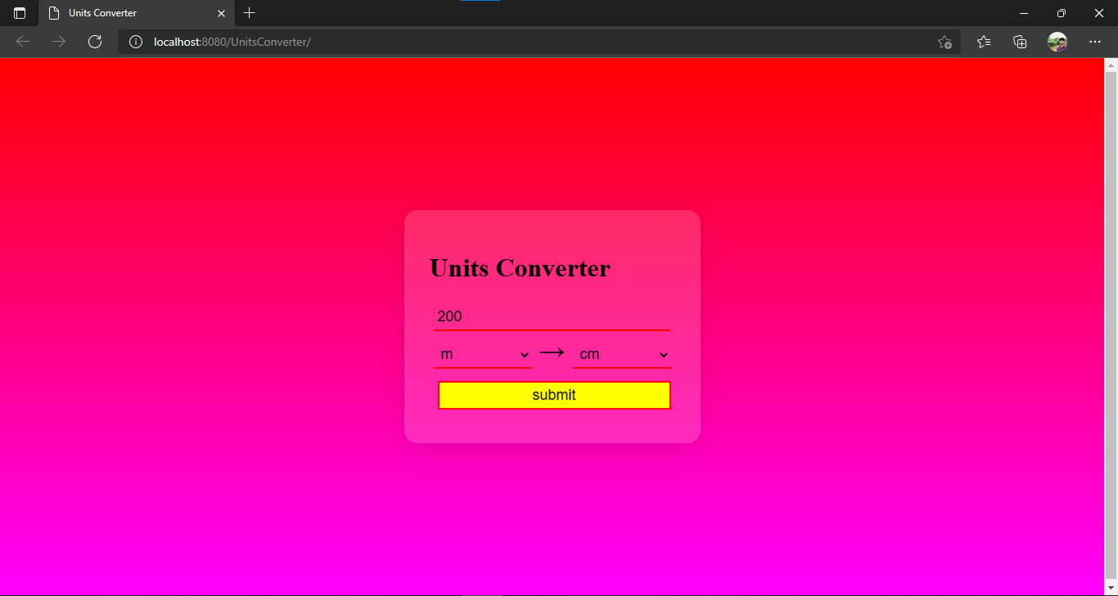

UnitsConverter.java

import java.io.IOException;
import java.io.PrintWriter;
import javax.servlet.ServletException;
import javax.servlet.http.HttpServlet;
import javax.servlet.http.HttpServletRequest;
import javax.servlet.http.HttpServletResponse;

public class UnitsConverter extends HttpServlet {

double Converter(double in,String unit){
double value=in;
switch(unit){
case "cm":
value/=0.01;
break;
case "m":
break;
case "km":
value/=1000;
break;
case "inches":
value*=39.370;
break;
case "feet":
value*=3.2808;
break;
}
return value;
}

@Override
protected void service(HttpServletRequest request, HttpServletResponse response)
throws ServletException, IOException {

response.setContentType("text/html;charset=UTF-8");
try (PrintWriter out = response.getWriter()) {
String from=request.getParameter("from_units");
String to=request.getParameter("to_units");
double in=Integer.parseInt(request.getParameter("input"));
double output=0;

switch(from){
case "m": output=Converter(in,to);
break;
case "cm": output=Converter(in/100,to);
break;
case "inches": output=Converter(in/39.370,to);
break;
case "km": output=Converter(in*1000,to);
break;
case "feet": output=Converter(in/3.2808,to);
break;
}

String css="<style>"
+ ".d{"
+ "position:absolute;"
+ "top:50%;"
+ "left:50%;"
+ "transform:translate(-50%,-50%);"
+ "}"
+ ".m{"
+ "color:yellow;"
+ "font-size:30px;"
+ ""
+ "}"
+ "body{"
+ "background: linear-gradient(#f00,#f0f);"
+ "height: 98vh;"
+ "}"
+ "</style>";

out.println("<!DOCTYPE html>");
out.println("<html>");
out.println("<head>");
out.println("<title>UnitsConverter</title>");
out.println(css);
out.println("</head>");
out.println("<body ><div class="+"d"+">");
out.println("<marquee class="+"m"+" direction="+"right"+" >This is Servlet</marquee>");
out.println("<h1>"+in+" "+from);
out.println("= "+String.format("%.4f", output)+" " +to+"</h1>");
out.println("</div></body>");
out.println("</html>");
}
}
}
Output:

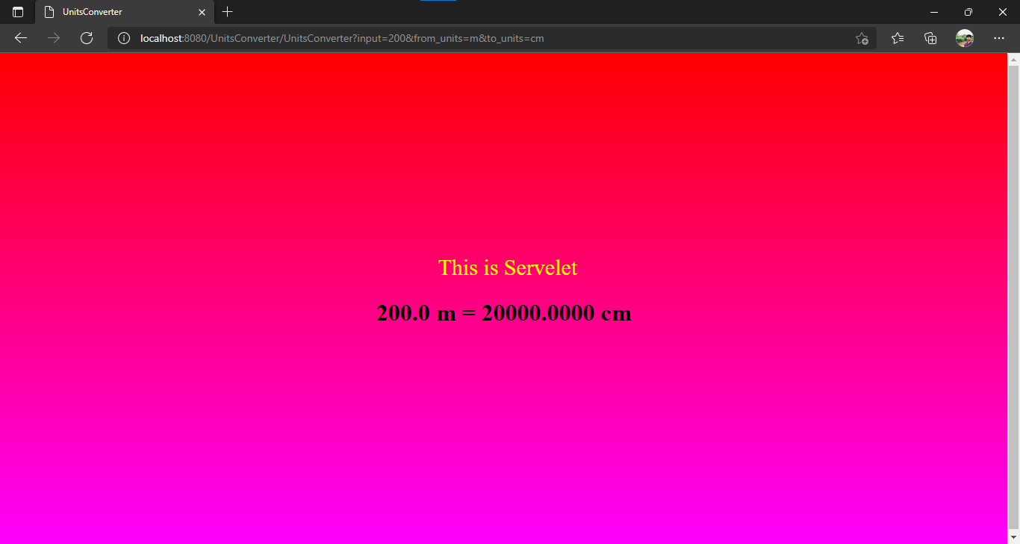
Experiment: 2 (a)
Aim: Create a web application to demonstrate State management technique using Session.
Application File Structure:

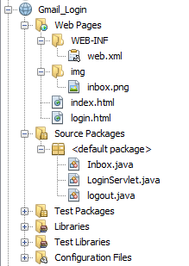

Source code:
index.html
<!DOCTYPE html>
<html>
<head>
<title>Index</title>
<meta charset="UTF-8">
<meta name="viewport" content="width=device-width, initial-scale=1.0">
<style>
a{
display: block;
text-decoration: none;
text-align: center;
border-radius: 20px;
padding:10px;
font-weight: bold;
font-size: 20px;
width: 100px;
float: left;
background-color: yellow;
color:black;
margin: 20px;
}
a:hover{
background-color: rgb(138, 232, 255);
box-shadow: 0 0 10px black;
}
body{
background-color: rgb(8, 255, 132);
}
</style>
</head>
<body>
<div>
<h1>Welcome to Gmail-Session</h1>
<a href="login.html">Login</a>
<a href="Inbox">Inbox</a>
<a href="logout">Logout</a>
</div>
</body>
</html>

Output:

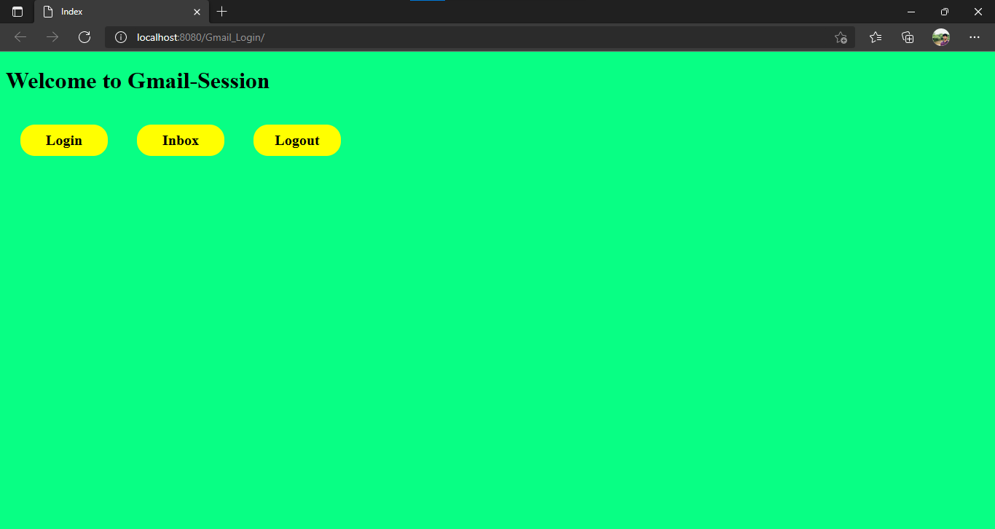

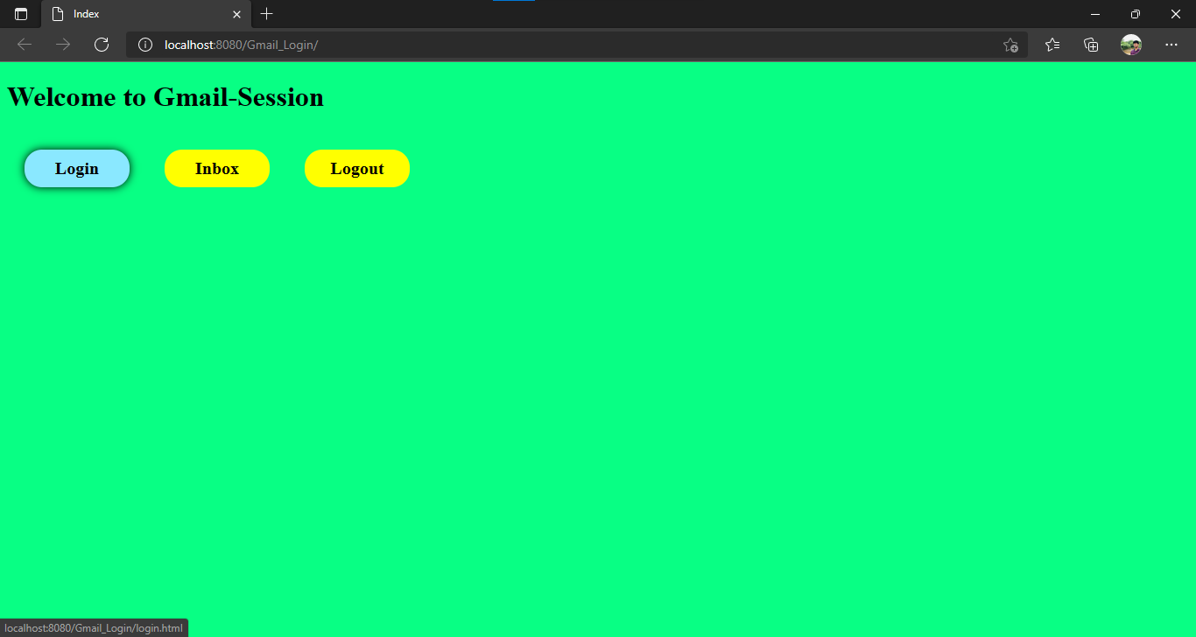

login.html

<!DOCTYPE html>
<html lang="en">
<head>
<meta charset="UTF-8">
<meta http-equiv="X-UA-Compatible" content="IE=edge">
<meta name="viewport" content="width=device-width, initial-scale=1.0">
<title>Login</title>
<style>
.login-box{
position: absolute;
top:50%;
left:50%;
transform:translate(-50%,-50%);
border-radius: 20px;
padding:20px;
width:350px;
height:350px;
background-color: rgb(236, 255, 67);
box-shadow: 0 0 10px black;
}
.in{
border:none ;
background: none;
outline:none;
width: 100%;
height: 100%;
font-size: 20px;
}
#btn{
width: 100%;
height: 100%;
padding:10px;
outline: none;
background-color: #1A73E8;
font-size: 20px;
font-weight: bold;
color:white;
border:none;
border-radius: 5px;
margin-top: 20px;
}
#btn:hover{
box-shadow: 0 0 10px black;
border:1px solid white;

}
body{
background-color: rgb(8, 255, 132);
}
table{
width:100%;
}
fieldset{
color:#1A73E8;
border: 2px solid blue;
border-radius: 5px;
}
h1{
font-size: 40px;
font-weight: bold;
border-bottom: 5px solid black;
float: left;
}
</style>
</head>
<body>
<div class="login-box">
<form action="LoginServlet" method="Post">
<table cellspacing=10>
<tr>
<td >
<h1>Login</h1>
</td>
</tr>
<tr>
<td>
<fieldset>
<legend>Username</legend>
<input class="in" type="text" name="username" required>
</fieldset>
</td>
</tr>
<tr>
<td>
<fieldset>
<legend>Password</legend>
<input class="in" type="password" name="password" required>
</fieldset>
</td>
</tr>
<tr>
<td align="center"><input id="btn" type="submit" value="Login"></td>
</tr>
</table>
</form>
</div>
</body>
</html>

Output:

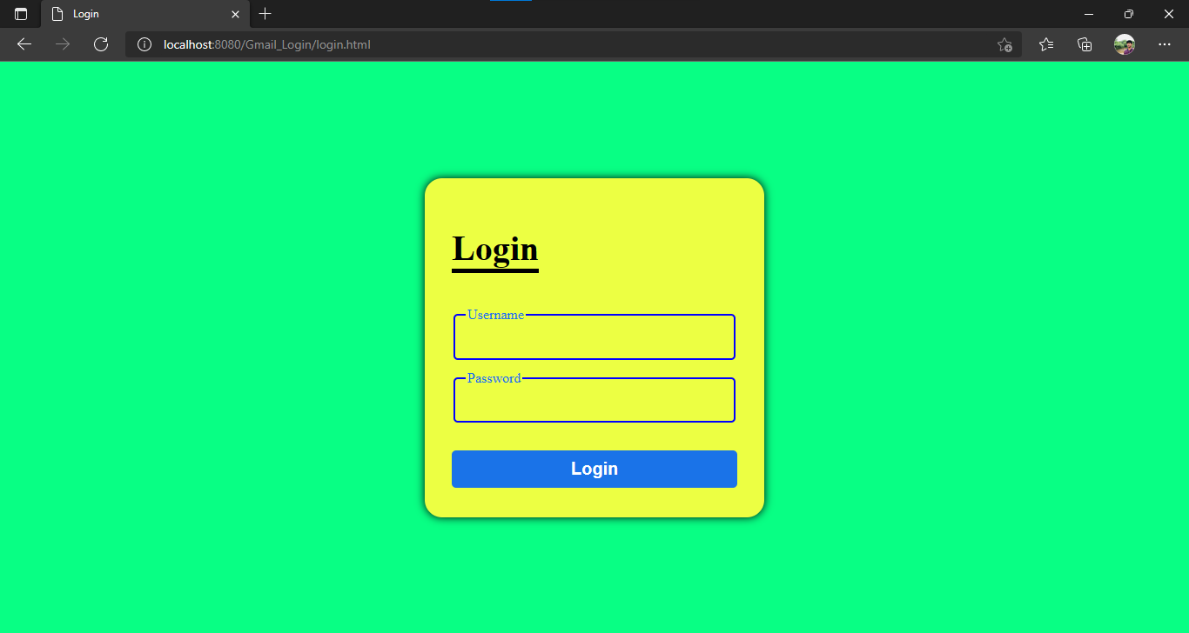

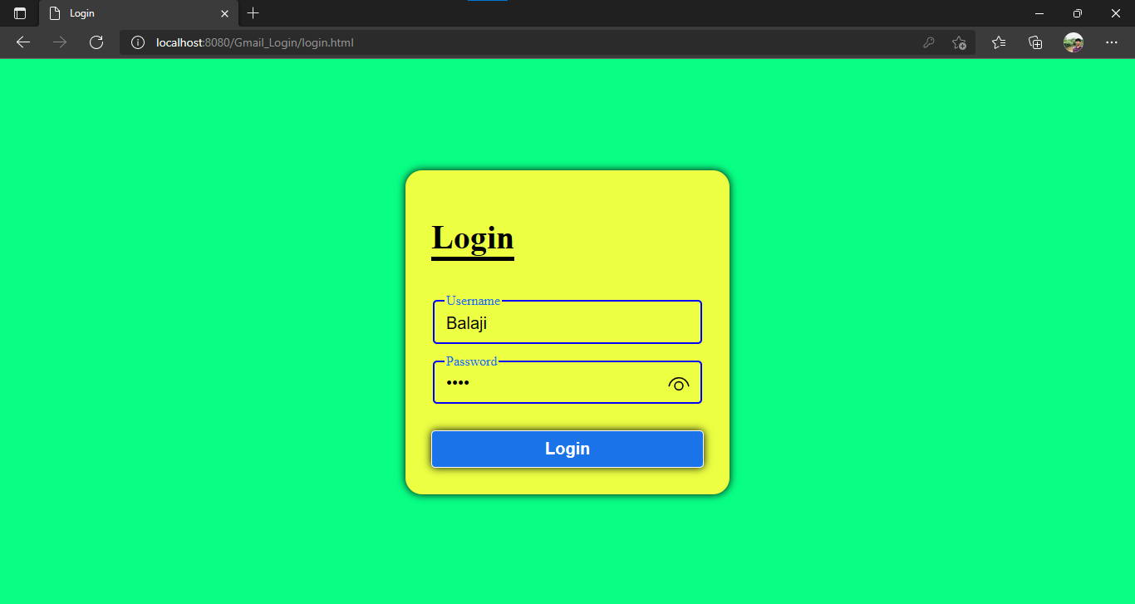

LoginServlet.java
import java.io.IOException;
import java.io.PrintWriter;
import javax.servlet.RequestDispatcher;
import javax.servlet.ServletException;
import javax.servlet.http.HttpServlet;
import javax.servlet.http.HttpServletRequest;
import javax.servlet.http.HttpServletResponse;
import javax.servlet.http.HttpSession;

public class LoginServlet extends HttpServlet {

@Override
protected void service (HttpServletRequest request, HttpServletResponse response)
throws ServletException, IOException {
response.setContentType("text/html;charset=UTF-8");
try (PrintWriter out = response.getWriter()) {
String username=request.getParameter("username");
String password=request.getParameter("password");
out.println("<Title>LogIn Servlet</title>");
if(password.equals("balu")){
HttpSession s=request.getSession();
s.setAttribute("name",username);
RequestDispatcher rd=request.getRequestDispatcher("Inbox");
rd.include(request, response);
}
else{
out.println("<body><h3 style='color:red;position:absolute;left:40%;top:40px' align=center>Invalid Username / Password !</h3><body>");
RequestDispatcher rd=request.getRequestDispatcher("login.html");
rd.include(request, response);
}

}
}
}

Output:

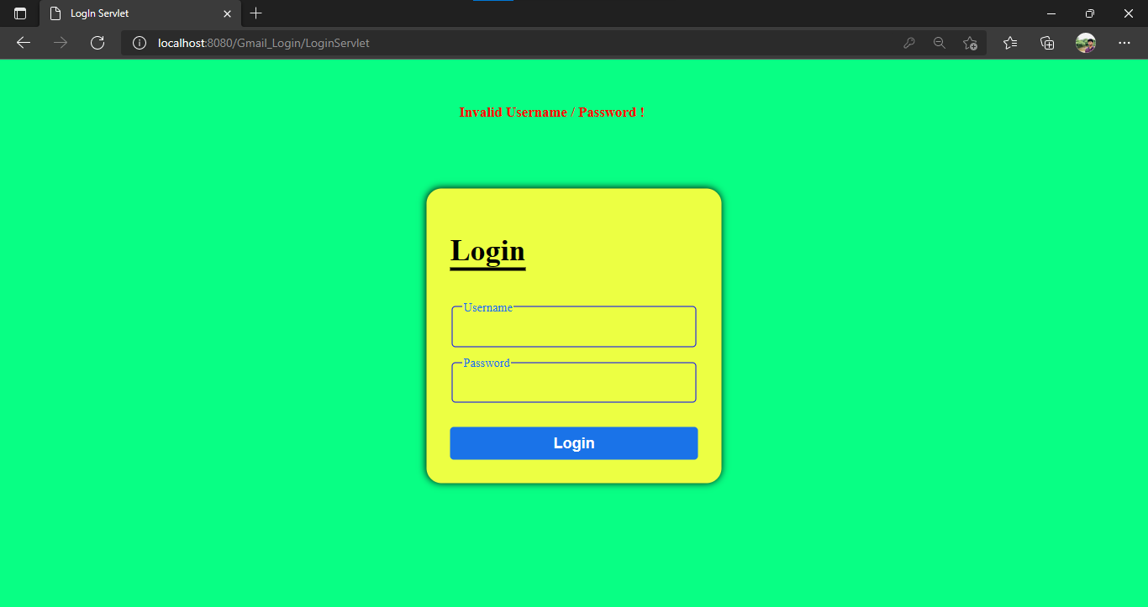

inbox.java
import java.io.IOException;
import java.io.PrintWriter;
import javax.servlet.ServletException;
import javax.servlet.http.HttpServlet;
import javax.servlet.http.HttpServletRequest;
import javax.servlet.http.HttpServletResponse;
import javax.servlet.http.HttpSession;

public class Inbox extends HttpServlet {

protected void processRequest(HttpServletRequest request, HttpServletResponse response)
throws ServletException, IOException {
response.setContentType("text/html;charset=UTF-8");
try (PrintWriter out = response.getWriter()) {
out.println("<Title>Inbox Servlet</title>");
HttpSession s=request.getSession(false);
if(s==null){
out.println("<body><h3 style='color:red;position:absolute;left:40%;top:40px' align=center>&#9940; Please login first...</h3><body>");
request.getRequestDispatcher("login.html").include(request, response);
}
else{
String username=(String)s.getAttribute("name");
out.println("<!DOCTYPE html>\n" +
"<html>\n" +
"<head>\n" +
" <title>Inbox</title>\n" +
" <style>\n" +
" body{\n" +
" background-color: rgb(8, 255, 132);\n" +
" }\n" +
" img{\n" +
" \n" +
" width: 150px;\n" +
" height:100px;\n" +
" }\n" +
" #hh{\n" +
" font-size: 90px;\n" +
" float:right;\n" +
" padding-top: 0;\n" +
" margin-top: 0;\n" +
" margin-left: 10px;\n" +
" margin-bottom: 0;\n" +
" }\n" +
" .heading{\n" +
" \n" +
" float:left;\n" +
" }\n" +
" .content{\n" +
" height:500px;\n" +
" width:98%;\n" +
" margin:3px;\n" +
" padding:10px;\n" +
" border:1px solid black;\n" +
" border-radius: 30px;\n" +
" background-color: rgba(0, 0, 0, 0.37);\n" +
" }\n" +
" table tr td{\n" +
" border-bottom: 1px solid black;\n" +
" \n" +
" padding:20px\n" +
" }\n" +
" table tr:hover:not(:last-child){\n" +
" background-color: rgba(0, 0, 0, 0.438);\n" +
" color:yellow;\n" +
" border-radius: 30px;\n" +
" }\n" +
" a{\n" +
" display: block;\n" +
" border-radius: 10px;\n" +
" padding:20px;\n" +
" font-size: 20px;\n" +
" background-color: yellow;\n" +
" text-decoration: none;\n" +
" width: 60px;\n" +
" margin: 20px;\n" +
" color:black;\n" +
" }\n" +
" a:hover{\n" +
" border:2px solid black;\n" +
" }\n" +
" .username{\n" +
" float:right;\n" +
" color:RED;\n" +
" }\n" +
" </style>\n" +
"</head>\n" +
"<body>\n" +
" <div class=heading>\n" +
" <img src=\"img\\inbox.png\" alt=\"inbox logo\">\n" +
" </div>\n" +
" <div class=heading>\n" +
" <h1 id=hh>INBOX</h1>\n" +
" </div>\n" +
" <div class=\"username\">\n" +
" <h1>welcome: "+username+"</h1>\n" +
" </div>\n" +
" <hr style=\"clear:left;background-color:black;height:1px;border:none\">\n" +
" <div class=\"content\">\n" +
" <table>\n" +
" <tr>\n" +
" <td><b>Microsoft</b></td>\n" +
" <td>\n" +
" Microsoft Corporation is an American multinational technology corporation which produces computer software, consumer electronics, personal computers, and related services\n" +
" </td>\n" +
" </tr>\n" +
" <tr>\n" +
" <td><b>Google</b></td>\n" +
" <td>\n" +
" Google Corporation is an American multinational technology corporation which produces computer software, consumer electronics, personal computers, and related services\n" +
" </td>\n" +
" </tr>\n" +
" <tr>\n" +
" <td><b>Apple</b></td>\n" +
" <td>\n" +
" Apple Corporation is an American multinational technology corporation which produces computer software, consumer electronics, personal computers, and related services\n" +
" </td>\n" +
" </tr>\n" +
" <tr>\n" +
" <td><b>Zoom</b></td>\n" +
" <td>\n" +
" Zoom Corporation is an American multinational technology corporation which produces computer software, consumer electronics, personal computers, and related services\n" +
" </td>\n" +
" </tr>\n" +
" <tr>\n" +
" <td><b>Microsoft</b></td>\n" +
" <td>\n" +
" Microsoft Corporation is an American multinational technology corporation which produces computer software, consumer electronics, personal computers, and related services\n" +
" </td>\n" +
" </tr>\n" +
" <tr>\n" +
" <td><b>Microsoft</b></td>\n" +
" <td>\n" +
" Microsoft Corporation is an American multinational technology corporation which produces computer software, consumer electronics, personal computers, and related services\n" +
" </td>\n" +
" </tr>\n" +
" <tr>\n" +
" <td colspan=2 align=center><a align=center href=\"logout\">Logout</a>\n</td>\n" +
" </tr>\n" +
" </table>\n" +
" " +
" </div>\n" +
"</body>\n" +
"</html>");
}

}
}
}
Output:

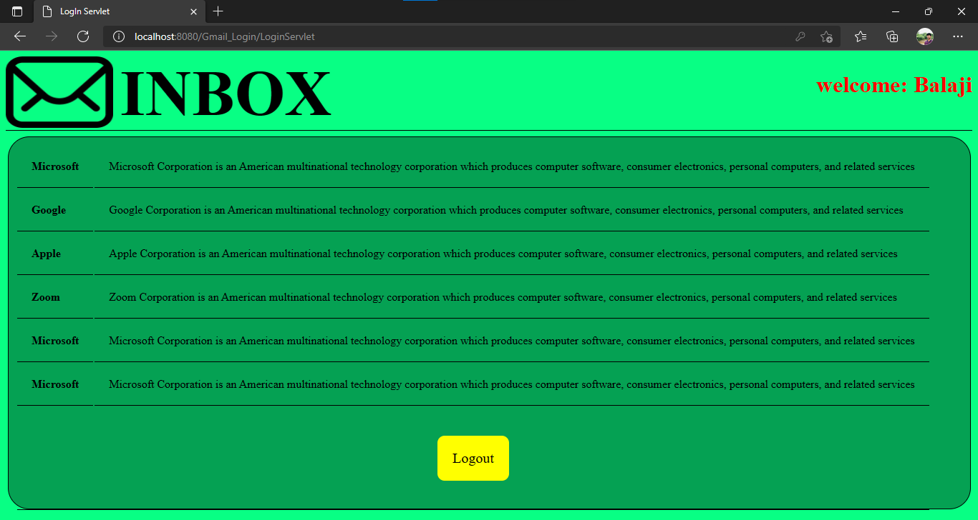

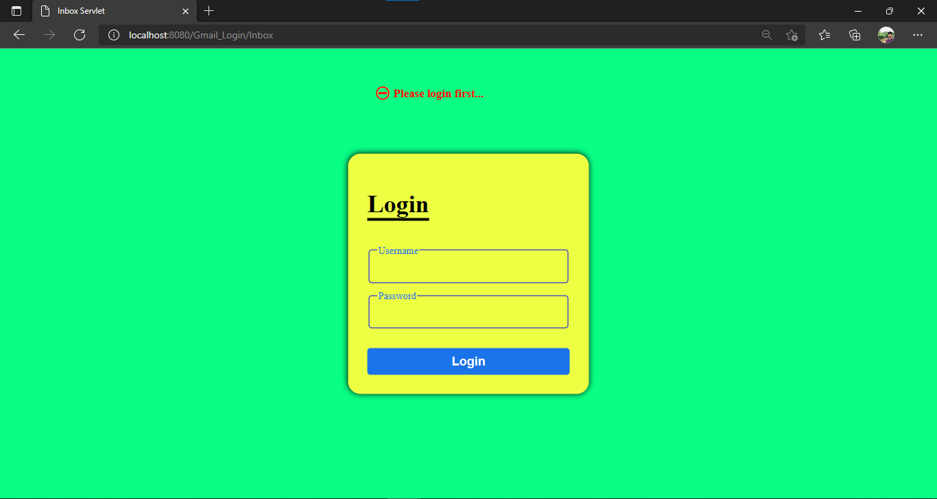

logout.java
import java.io.IOException;
import java.io.PrintWriter;
import javax.servlet.ServletException;
import javax.servlet.http.HttpServlet;
import javax.servlet.http.HttpServletRequest;
import javax.servlet.http.HttpServletResponse;
import javax.servlet.http.HttpSession;

public class logout extends HttpServlet {

protected void processRequest(HttpServletRequest request, HttpServletResponse response)
throws ServletException, IOException {
response.setContentType("text/html;charset=UTF-8");
try (PrintWriter out = response.getWriter()) {

HttpSession s=request.getSession(false);
if(s==null){
out.println("<body><h3 style='color:red;position:absolute;left:40%;top:40px' align=center>&#9940; Please login first...</h3><body>");
request.getRequestDispatcher("login.html").include(request, response);
}
else{
s.invalidate();
out.println("<Title>LogoutServlet</title>");
out.println("<h1>LogOut Successfully</h1>");
request.getRequestDispatcher("index.html").include(request, response);
}
}
}
}

Output:

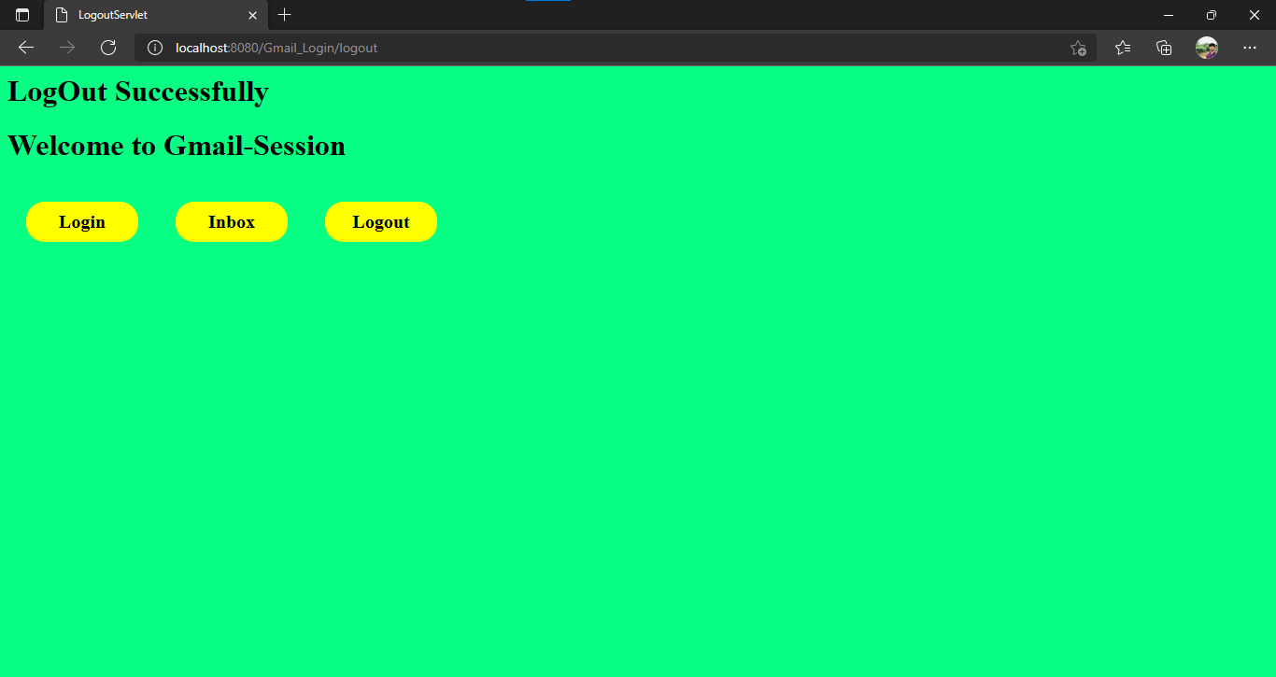

Experiment: 2 (b)
Aim: Create a web application to demonstrate State management technique using Cookies.
Application File Structure:

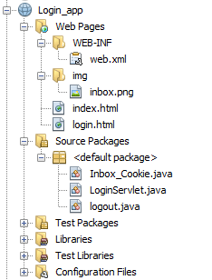

Source code:
index.html
<!DOCTYPE html>
<html>
<head>
<title>Index</title>
<meta charset="UTF-8">
<meta name="viewport" content="width=device-width, initial-scale=1.0">
<style>
a{
display: block;
text-decoration: none;
text-align: center;
border-radius: 20px;
padding:10px;
font-weight: bold;
font-size: 20px;
width: 100px;
float: left;
background-color: yellow;
color:black;
margin: 20px;
}
a:hover{
background-color: rgb(138, 232, 255);
box-shadow: 0 0 10px black;
}
body{
background-color: rgb(8, 255, 132);
}
</style>
</head>
<body>
<div>
<h1>Welcome to Gmail-Cookie</h1>
<a href="login.html">Login</a>
<a href="Inbox_Cookie">Inbox</a>
<a href="logout">Logout</a>
</div>
</body>
</html>

Output:

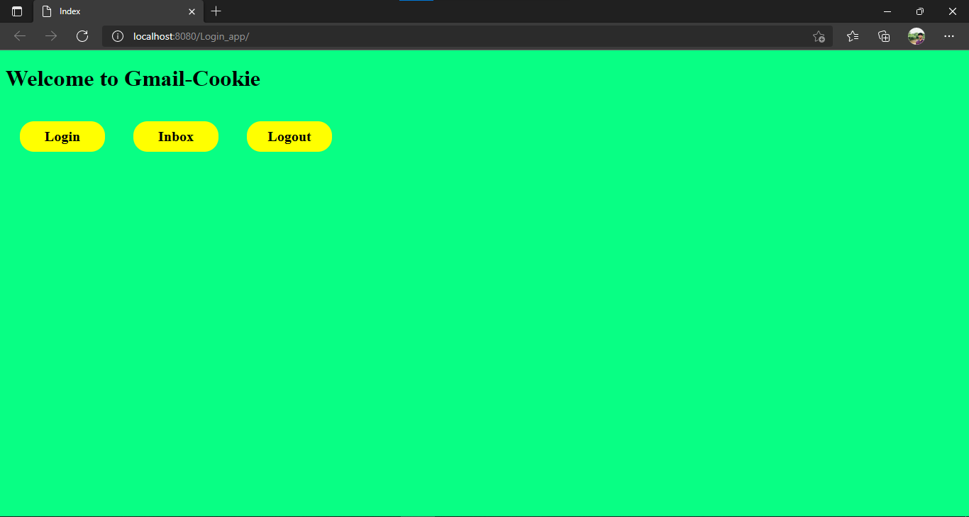

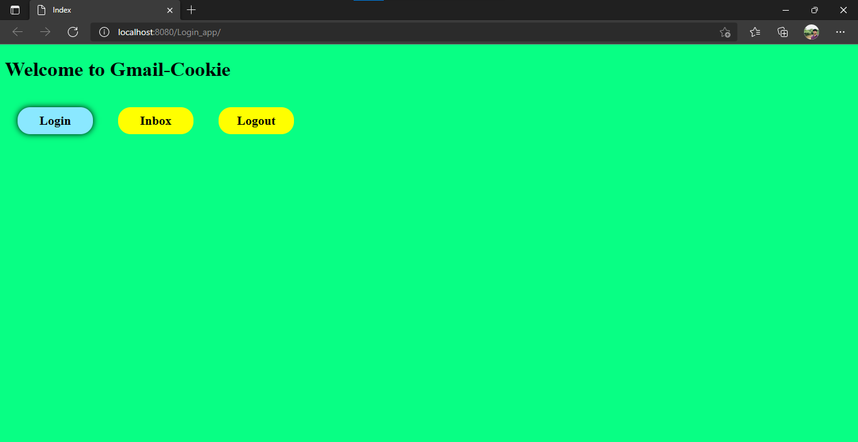

login.html

<!DOCTYPE html>
<html lang="en">
<head>
<meta charset="UTF-8">
<meta http-equiv="X-UA-Compatible" content="IE=edge">
<meta name="viewport" content="width=device-width, initial-scale=1.0">
<title>Login</title>
<style>
.login-box{
position: absolute;
top:50%;
left:50%;
transform:translate(-50%,-50%);
border-radius: 20px;
padding:20px;
width:350px;
height:350px;
background-color: rgb(236, 255, 67);
box-shadow: 0 0 10px black;
}
.in{
border:none ;
background: none;
outline:none;
width: 100%;
height: 100%;
font-size: 20px;
}
#btn{
width: 100%;
height: 100%;
padding:10px;
outline: none;
background-color: #1A73E8;
font-size: 20px;
font-weight: bold;
color:white;
border:none;
border-radius: 5px;
margin-top: 20px;
}
#btn:hover{
box-shadow: 0 0 10px black;
border:1px solid white;

}
body{
background-color: rgb(8, 255, 132);
}
table{
width:100%;
}
fieldset{
color:#1A73E8;
border: 2px solid blue;
border-radius: 5px;
}
h1{
font-size: 40px;
font-weight: bold;
border-bottom: 5px solid black;
float: left;
}
</style>
</head>
<body>
<div class="login-box">
<form action="LoginServlet" method="Post">
<table cellspacing=10>
<tr>
<td >
<h1>Login</h1>
</td>
</tr>
<tr>
<td>
<fieldset>
<legend>Username</legend>
<input class="in" type="text" name="username" required>
</fieldset>
</td>
</tr>
<tr>
<td>
<fieldset>
<legend>Password</legend>
<input class="in" type="password" name="password" required>
</fieldset>
</td>
</tr>
<tr>
<td align="center"><input id="btn" type="submit" value="Login"></td>
</tr>
</table>
</form>
</div>
</body>
</html>

Output:

LoginServlet.java
import java.io.IOException;
import java.io.PrintWriter;
import javax.servlet.RequestDispatcher;
import javax.servlet.ServletException;
import javax.servlet.http.Cookie;
import javax.servlet.http.HttpServlet;
import javax.servlet.http.HttpServletRequest;
import javax.servlet.http.HttpServletResponse;
import javax.servlet.http.HttpSession;

public class LoginServlet extends HttpServlet {

@Override
protected void service(HttpServletRequest request, HttpServletResponse response)
throws ServletException, IOException {
response.setContentType("text/html;charset=UTF-8");
try (PrintWriter out = response.getWriter()) {

String username=request.getParameter("username");
String password=request.getParameter("password");

out.println("<Title>LogIn Servlet</title>");
if(password.equals("balu")){
Cookie c=new Cookie("name",username);
response.addCookie(c);

RequestDispatcher rd=request.getRequestDispatcher("Inbox_Cookie");
rd.include(request, response);
}
else{
out.println("<body><h3 style='color:red;position:absolute;left:40%;top:40px' align=center>Invalid Username / Password !</h3><body>");
RequestDispatcher rd=request.getRequestDispatcher("login.html");
rd.include(request, response);
}

}
}

Output:

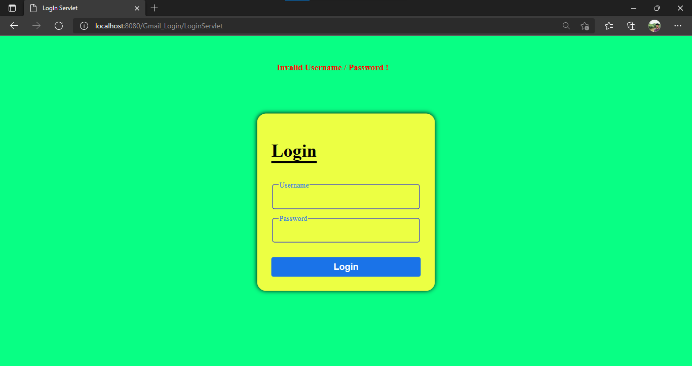

Inbox_Cookie.java
import java.io.IOException;
import java.io.PrintWriter;
import javax.servlet.ServletException;
import javax.servlet.http.Cookie;
import javax.servlet.http.HttpServlet;
import javax.servlet.http.HttpServletRequest;
import javax.servlet.http.HttpServletResponse;

public class Inbox_Cookie extends HttpServlet {

@Override
protected void service(HttpServletRequest request, HttpServletResponse response)
throws ServletException, IOException {
response.setContentType("text/html;charset=UTF-8");
try (PrintWriter out = response.getWriter()) {
out.println("<Title>Inbox Servlet</title>");
Cookie[] c=request.getCookies();
if(c==null){
out.println("<body><h3 style='color:red;position:absolute;left:40%;top:40px' align=center>&#9940; Please login first...</h3><body>");
request.getRequestDispatcher("login.html").include(request, response);
}
else{
String username=(String)c[0].getValue();
out.println("<!DOCTYPE html>\n" +
"<html>\n" +
"<head>\n" +
" <title>Inbox</title>\n" +
" <style>\n" +
" body{\n" +
" background-color: rgb(8, 255, 132);\n" +
" }\n" +
" img{\n" +
" \n" +
" width: 150px;\n" +
" height:100px;\n" +
" }\n" +
" #hh{\n" +
" font-size: 90px;\n" +
" float:right;\n" +
" padding-top: 0;\n" +
" margin-top: 0;\n" +
" margin-left: 10px;\n" +
" margin-bottom: 0;\n" +
" }\n" +
" .heading{\n" +
" \n" +
" float:left;\n" +
" }\n" +
" .content{\n" +
" height:500px;\n" +
" width:98%;\n" +
" margin:3px;\n" +
" padding:10px;\n" +
" border:1px solid black;\n" +
" border-radius: 30px;\n" +
" background-color: rgba(0, 0, 0, 0.37);\n" +
" }\n" +
" table tr td{\n" +
" border-bottom: 1px solid black;\n" +
" \n" +
" padding:20px\n" +
" }\n" +
" table tr:hover:not(:last-child){\n" +
" background-color: rgba(0, 0, 0, 0.438);\n" +
" color:yellow;\n" +
" border-radius: 30px;\n" +
" }\n" +
" a{\n" +
" display: block;\n" +
" border-radius: 10px;\n" +
" padding:20px;\n" +
" font-size: 20px;\n" +
" background-color: yellow;\n" +
" text-decoration: none;\n" +
" width: 60px;\n" +
" margin: 20px;\n" +
" color:black;\n" +
" }\n" +
" a:hover{\n" +
" border:2px solid black;\n" +
" }\n" +
" .username{\n" +
" float:right;\n" +
" color:RED;\n" +
" }\n" +
" </style>\n" +
"</head>\n" +
"<body>\n" +
" <div class=heading>\n" +
" <img src=\"img\\inbox.png\" alt=\"inbox logo\">\n" +
" </div>\n" +
" <div class=heading>\n" +
" <h1 id=hh>INBOX</h1>\n" +
" </div>\n" +
" <div class=\"username\">\n" +
" <h1>welcome: "+username+"</h1>\n" +
" </div>\n" +
" <hr style=\"clear:left;background-color:black;height:1px;border:none\">\n" +
" <div class=\"content\">\n" +
" <table>\n" +
" <tr>\n" +
" <td><b>Microsoft</b></td>\n" +
" <td>\n" +
" Microsoft Corporation is an American multinational technology corporation which produces computer software, consumer electronics, personal computers, and related services\n" +
" </td>\n" +
" </tr>\n" +
" <tr>\n" +
" <td><b>Google</b></td>\n" +
" <td>\n" +
" Google Corporation is an American multinational technology corporation which produces computer software, consumer electronics, personal computers, and related services\n" +
" </td>\n" +
" </tr>\n" +
" <tr>\n" +
" <td><b>Apple</b></td>\n" +
" <td>\n" +
" Apple Corporation is an American multinational technology corporation which produces computer software, consumer electronics, personal computers, and related services\n" +
" </td>\n" +
" </tr>\n" +
" <tr>\n" +
" <td><b>Zoom</b></td>\n" +
" <td>\n" +
" Zoom Corporation is an American multinational technology corporation which produces computer software, consumer electronics, personal computers, and related services\n" +
" </td>\n" +
" </tr>\n" +
" <tr>\n" +
" <td><b>Microsoft</b></td>\n" +
" <td>\n" +
" Microsoft Corporation is an American multinational technology corporation which produces computer software, consumer electronics, personal computers, and related services\n" +
" </td>\n" +
" </tr>\n" +
" <tr>\n" +
" <td><b>Microsoft</b></td>\n" +
" <td>\n" +
" Microsoft Corporation is an American multinational technology corporation which produces computer software, consumer electronics, personal computers, and related services\n" +
" </td>\n" +
" </tr>\n" +
" <tr>\n" +
" <td colspan=2 align=center><a align=center href=\"logout\">Logout</a>\n</td>\n" +
" </tr>\n" +
" </table>\n" +
" " +
" </div>\n" +
"</body>\n" +
"</html>");
}
}
}
}
Output:

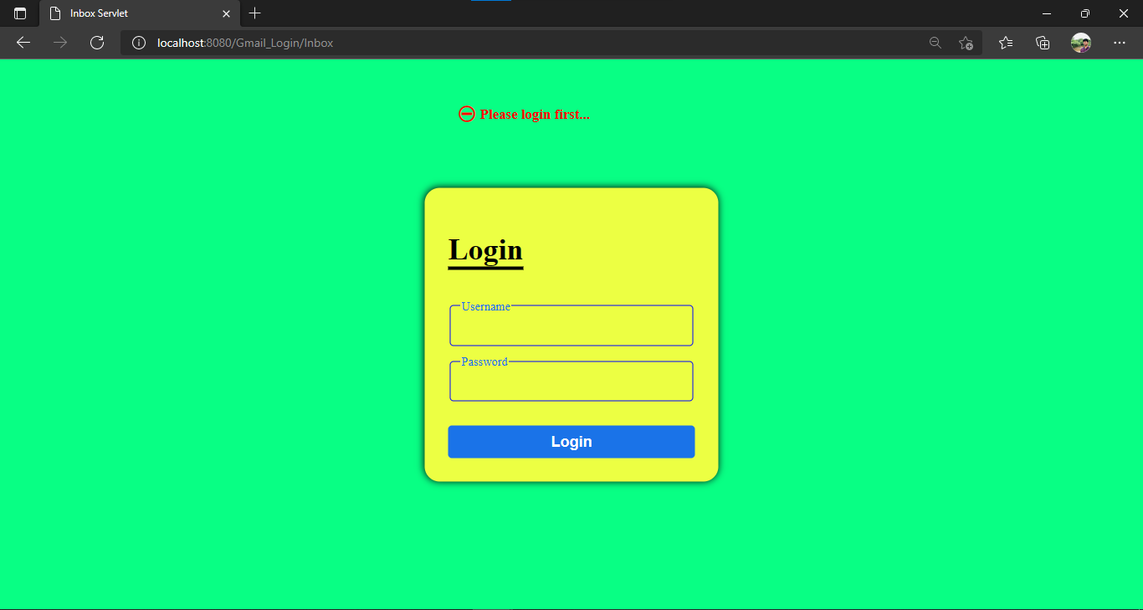

logout.java
import java.io.IOException;
import java.io.PrintWriter;
import javax.servlet.ServletException;
import javax.servlet.http.Cookie;
import javax.servlet.http.HttpServlet;
import javax.servlet.http.HttpServletRequest;
import javax.servlet.http.HttpServletResponse;
public class logout extends HttpServlet {

@Override
protected void service(HttpServletRequest request, HttpServletResponse response)
throws ServletException, IOException {
response.setContentType("text/html;charset=UTF-8");
try (PrintWriter out = response.getWriter()) {

Cookie[] c=request.getCookies();

if(c==null){
out.println("<body><h3 style='color:red;position:absolute;left:40%;top:40px' align=center>&#9940; Please login first...</h3><body>");
request.getRequestDispatcher("login.html").include(request, response);

}
else{
c[0].setMaxAge(0);
response.addCookie(c[0]);
out.println("<Title>LogoutServlet</title>");
out.println("<h1>LogOut Successfully</h1>");
request.getRequestDispatcher("index.html").include(request, response);
}
}
}

Output:

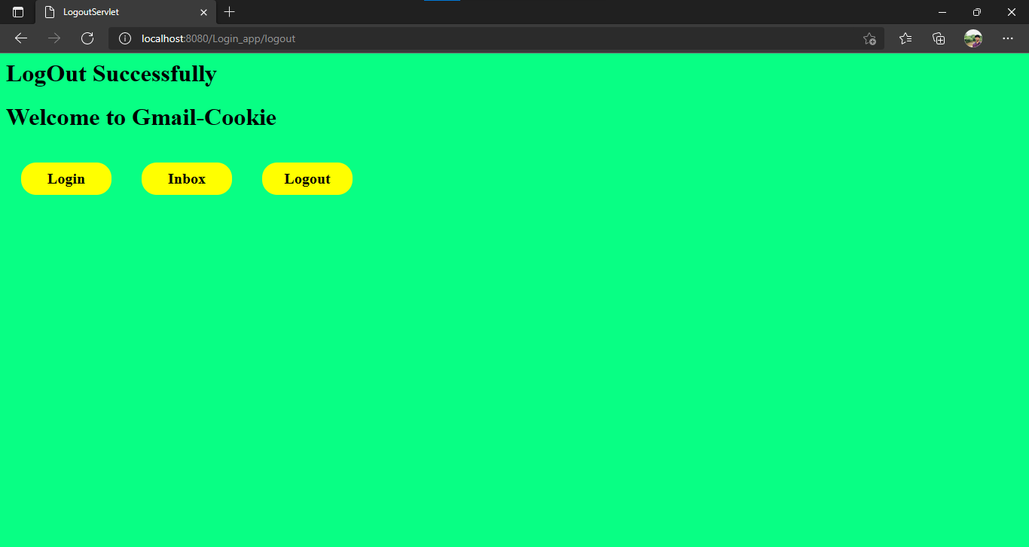

Experiment : 3 (a)
Aim: Create a web application to demonstrate JSP Core tags.
Application File Structure:

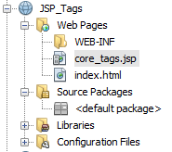

Source code:
index.html
<!DOCTYPE html>
<html>
<head>
<title>Index</title>
<meta charset="UTF-8">
<meta name="viewport" content="width=device-width, initial-scale=1.0">
</head>
<body>
<a href="core_tags.jsp">JSP_Core_Tags</a>
</body>
</html>

Output:
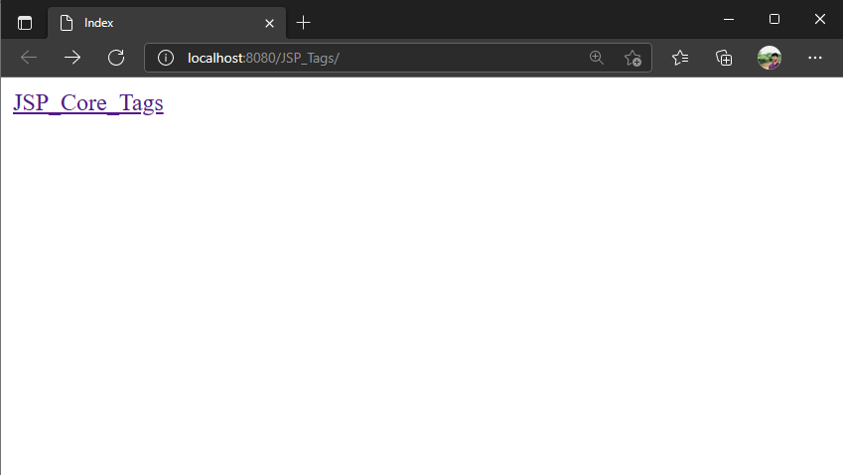

core_tags.jsp

<%@page contentType="text/html" pageEncoding="UTF-8"%>
<%@ taglib uri="http://java.sun.com/jsp/jstl/core" prefix="c" %>
<!DOCTYPE html>
<html>
<head><meta http-equiv="Content-Type" content="text/html; charset=UTF-8">
<title>JSP Core Tags</title></head>
<body>
<h1>JSP Core Tags</h1>
<h3>set, out : </h3>
<c:set var="income" scope="session" value="${4000*4}"/>
<p>Your income is : <c:out value="${income}"/></p>
<h3>choose_when_otherwise :</h3>
<c:choose>
<c:when test="${income <= 1000}">
Income is not good.
</c:when>
<c:when test="${income > 10000}">
Income is very good.
</c:when>
<c:otherwise>
Income is undetermined...
</c:otherwise>
</c:choose>
<h3>remove :</h3>
<c:remove var="income"/>
<p>After Remove Value is: <c:out value="${income}"/></p>
<h3>catch : </h3>
<c:catch var ="catchtheException">
<% int x = 2/0;%>
</c:catch>
<h3>if : </h3>
<c:if test = "${catchtheException != null}">
<p>The type of exception is : ${catchtheException} <br />
There is an exception: ${catchtheException.message}</p>
</c:if>
<h3>forEach :</h3>
<c:forEach var="j" begin="1" end="3">
<c:out value="Item${j}"/><p>
</c:forEach>
<h3>forTokens :</h3>
<c:forTokens items="Pravali,Balu,Raja,Karthik" delims="," var="name">
<c:out value="${name}"/><p>
</c:forTokens>
<h3>url, param :</h3>
<c:url value="/index.jsp" var="completeURL">
<c:param name="Id" value="37"/>
<c:param name="user" value="balu"/>
</c:url>
<c:out value="URL : ${completeURL}"/>
</body></html>
Output:

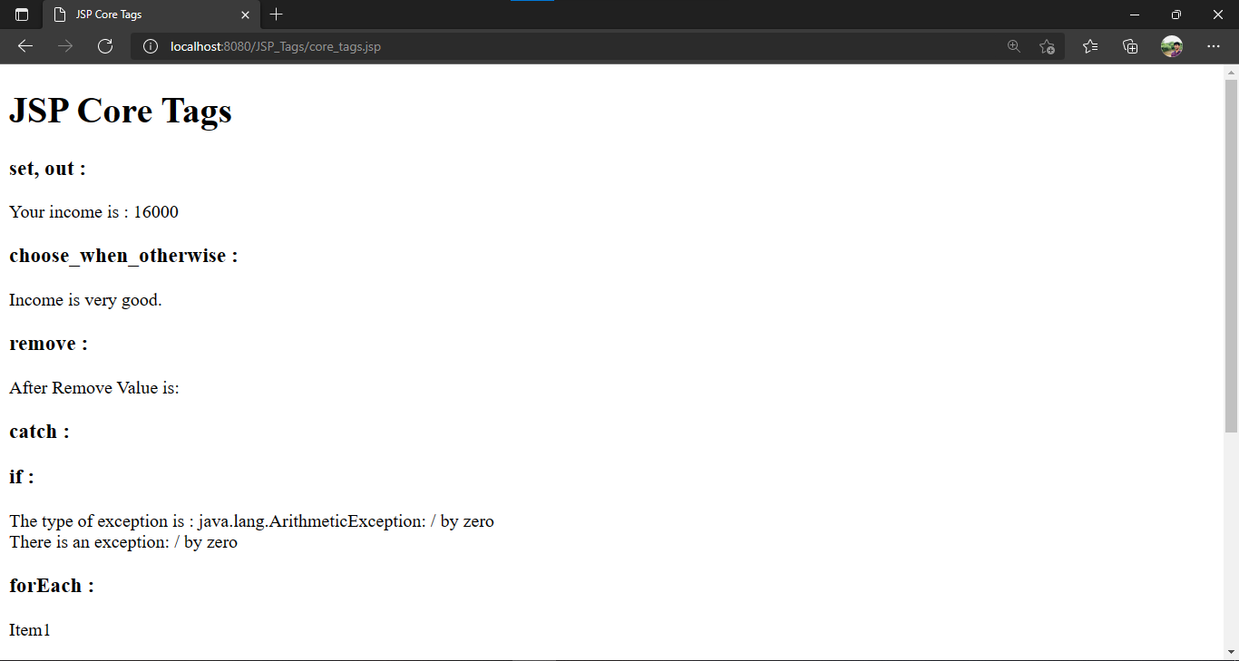

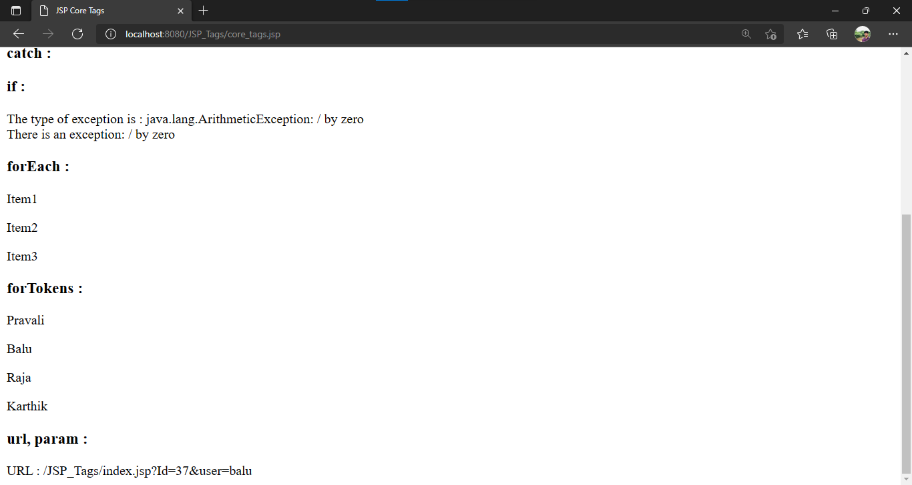
Experiment : 3 (b)
Aim: Create a web application to demonstrate JSP Custom tag.
Application File Structure:
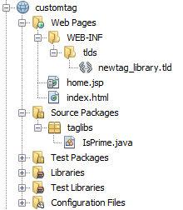

Source code:
index.html
<!DOCTYPE html>
<html>
<head>
<title>Index</title>
<meta charset="UTF-8">
<meta name="viewport" content="width=device-width, initial-scale=1.0">
</head>
<body>
<div>
<a href="home.jsp">Goto home jsp</a>
</div>
</body>
</html>

Output:

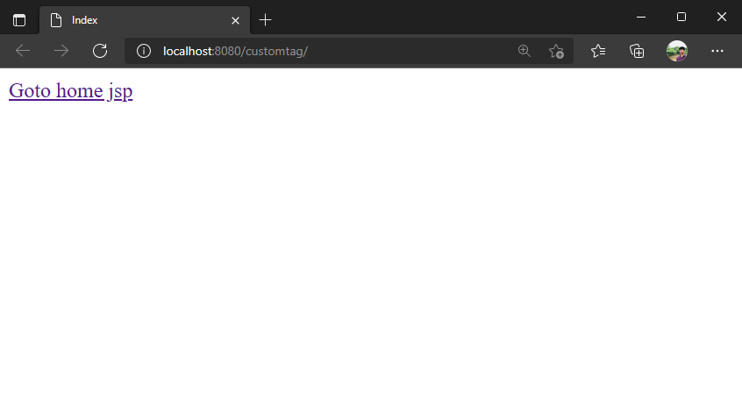

IsPrime.java

package taglibs;
import java.io.*;
import javax.servlet.jsp.*;
import javax.servlet.jsp.tagext.*;

public class IsPrime extends SimpleTagSupport{

StringWriter sw = new StringWriter();
@Override
public void doTag() throws JspException,IOException{
JspWriter out=getJspContext().getOut();
getJspBody().invoke(sw);
int num=Integer.parseInt(sw.toString());

//check prime or not
int count=0;
for(int i=2;i<num;i++){
if(num%i == 0){
count++;
break;
}
}
if(count > 0)
out.println(num+" is not a Prime Number");
else
out.println(num+" is a Prime Number");

}
}
newtag_library.tld

<?xml version="1.0" encoding="UTF-8"?>
<taglib version="2.1" xmlns="http://java.sun.com/xml/ns/javaee" xmlns:xsi="http://www.w3.org/2001/XMLSchema-instance" xsi:schemaLocation="http://java.sun.com/xml/ns/javaee http://java.sun.com/xml/ns/javaee/web-jsptaglibrary_2_1.xsd">
<tlib-version>1.0</tlib-version>
<short-name>newtag_library</short-name>
<uri>/WEB-INF/tlds/newtag_library</uri>
<tag>
<name>IsPrime</name>
<tag-class>taglibs.IsPrime</tag-class>
<body-content>scriptless</body-content>
</tag>
</taglib>

home.jsp

<%@page contentType="text/html" pageEncoding="UTF-8"%>
<%@taglib prefix="c" uri="WEB-INF/tlds/newtag_library.tld"%>
<!DOCTYPE html>
<html>
<head>
<meta http-equiv="Content-Type" content="text/html; charset=UTF-8">
<title>JSP Page</title>
</head>
<body>
<c:IsPrime>2</c:IsPrime>
</body>

</html>

Output:

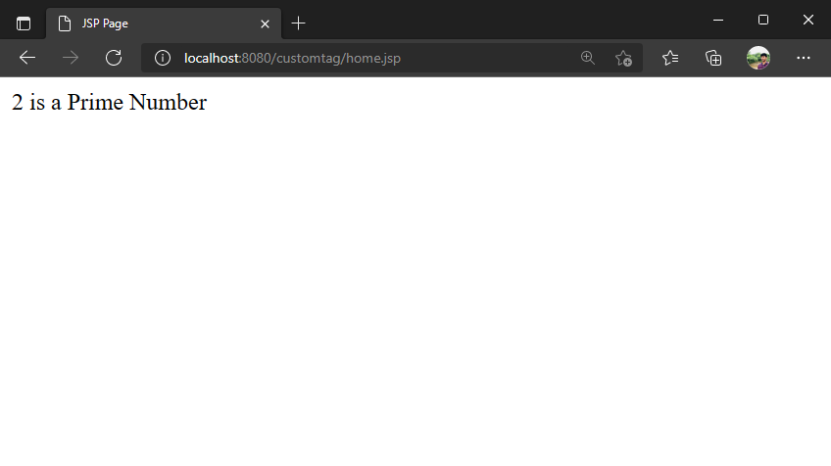

Experiment : 4
Aim: Create a web application to demonstrate JSF Managed beans.
Application File Structure:

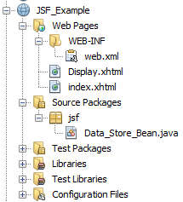

Source code:
index.xhtml
<?xml version='1.0' encoding='UTF-8' ?>
<!DOCTYPE html PUBLIC "-//W3C//DTD XHTML 1.0 Transitional//EN" "http://www.w3.org/TR/xhtml1/DTD/xhtml1-transitional.dtd">
<html xmlns="http://www.w3.org/1999/xhtml"
xmlns:f="http://xmlns.jcp.org/jsf/core"
xmlns:h="http://xmlns.jcp.org/jsf/html">
<h:head>
<title>Form</title>
</h:head>
<h:body>
<h:form>
<h2>Student Details</h2>
<table>
<tr>
<td>First Name </td>
<td><h:inputText id="fname" required="true" value="#{d_bean.fname}"></h:inputText> </td>
</tr>
<tr>
<td>Last Name </td>
<td><h:inputText id="lname" required="true" value="#{d_bean.lname}"></h:inputText> </td>
</tr>
<tr>
<td>REG No </td>
<td><h:inputText id="reg" required="true" value="#{d_bean.reg}">
<f:validateRegex pattern = "([Y,L][0-9]{2}[A-Z]{3}[0-9]{3})" />
</h:inputText> </td>
</tr>
<tr>
<td>Gender </td>
<td><h:selectOneRadio id="gender" required="true" value="#{d_bean.gender}">
<f:selectItem itemLabel="Male" itemValue="male"></f:selectItem>
<f:selectItem itemLabel="Female" itemValue="female"></f:selectItem>
</h:selectOneRadio>
</td>
</tr>
<tr>
<td>Date of Birth </td>
<td><h:inputText id="dob" value="#{d_bean.dob}">
<f:convertDateTime pattern="dd-MM-yyyy"></f:convertDateTime>
</h:inputText> <i>(dd-mm-yyyy)</i>
</td>
</tr>
<tr>
<td>Percentage </td>
<td>
<h:inputText value="#{d_bean.percent}" >
<f:convertNumber type = "percent" />
</h:inputText>
</td>
</tr>
<tr>
<td>Address </td>
<td><h:inputTextarea id="address" required="true" value="#{d_bean.address}"></h:inputTextarea></td>
</tr>

<tr>
<td>Email Id </td>
<td><h:inputText id="email" required="true" value="#{d_bean.email}" ></h:inputText></td>
</tr>
<tr>
<td>Mobile</td>
<td><h:inputText id="mobile" value="#{d_bean.mobile}">
<f:validateLength minimum = "10" maximum = "10" />
</h:inputText></td>
</tr>
<tr>
<td>Department</td>
<td>
<h:selectOneMenu id="dept" value="#{d_bean.dept}">
<f:selectItem itemLabel="IT" itemValue="IT"></f:selectItem>
<f:selectItem itemLabel="CSE" itemValue="CSE"></f:selectItem>
<f:selectItem itemLabel="EEE" itemValue="EEE"></f:selectItem>
<f:selectItem itemLabel="ECE" itemValue="ECE"></f:selectItem>
</h:selectOneMenu>
</td>
</tr>
<tr>
<td>Languages</td>
<td>
<h:selectManyCheckbox value="#{d_bean.langs}">
<f:selectItem itemLabel="C" itemValue="C"></f:selectItem>
<f:selectItem itemLabel="C++" itemValue="C++"></f:selectItem>
<f:selectItem itemLabel="Java" itemValue="Java"></f:selectItem>
<f:selectItem itemLabel="Python" itemValue="Python"></f:selectItem>
</h:selectManyCheckbox>
</td>
</tr>
<tr>
<td>
<h:commandButton value="Submit" action="Display.xhtml" />
</td>
</tr>
</table>
</h:form>
</h:body>
</html>

Output:

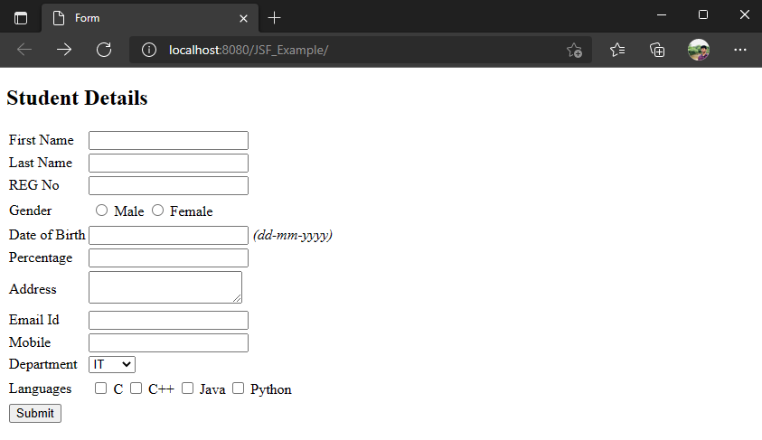

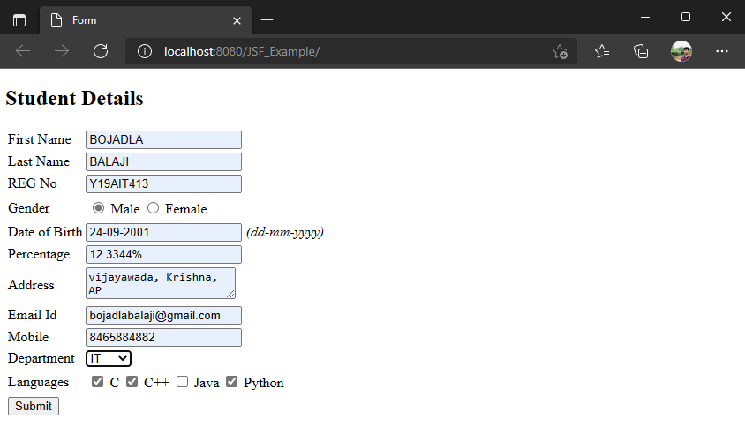

Data_Store_Bean.java
package jsf;

import javax.inject.Named;
import javax.enterprise.context.RequestScoped;

@Named(value = "d_bean")
@RequestScoped
public class Data_Store_Bean {
private String fname,lname,reg;
private String gender,dob,address;
private String email,mobile,dept,percent;
private String langs[];

public Data_Store_Bean(){}

public String getFname() {
return fname;
}

public void setFname(String fname) {
this.fname = fname;
}
public String getPercent() {
return percent;
}

public void setPercent(String percent) {
this.percent = percent;
}

public String getLname() {
return lname;
}

public void setLname(String lname) {
this.lname = lname;
}

public String getReg() {
return reg;
}

public void setReg(String reg) {
this.reg = reg;
}

public String getGender() {
return gender;
}

public void setGender(String gender) {
this.gender = gender;
}

public String getDob() {
return dob;
}

public void setDob(String dob) {
this.dob = dob;
}

public String getAddress() {
return address;
}

public void setAddress(String address) {
this.address = address;
}

public String getEmail() {
return email;
}

public void setEmail(String email) {
this.email = email;
}

public String getMobile() {
return mobile;
}

public void setMobile(String mobile) {
this.mobile = mobile;
}

public String getDept() {
return dept;
}

public void setDept(String dept) {
this.dept = dept;
}

public String[] getLangs() {
return langs;
}

public void setLangs(String langs[]) {
this.langs = langs;
}

}

Display.xhtml
<?xml version='1.0' encoding='UTF-8' ?>
<!DOCTYPE html PUBLIC "-//W3C//DTD XHTML 1.0 Transitional//EN" "http://www.w3.org/TR/xhtml1/DTD/xhtml1-transitional.dtd">
<html xmlns="http://www.w3.org/1999/xhtml"
xmlns:h="http://xmlns.jcp.org/jsf/html"
xmlns:f="http://xmlns.jcp.org/jsf/core"
xmlns:ui="http://java.sun.com/jsf/facelets">
<h:head>
<title>Student Details</title>
</h:head>
<h:body>

<h2>Student Details</h2>
<table>
<tr>
<td>First Name </td>
<td><b>: #{d_bean.fname}</b> </td>
</tr>
<tr>
<td>Last Name </td>
<td><b>: #{d_bean.lname}</b> </td>
</tr>
<tr>
<td>REG No </td>
<td><b>: #{d_bean.reg}</b> </td>
</tr>
<tr>
<td>Gender </td>
<td><b>: #{d_bean.gender}</b> </td>
</tr>
<tr>
<td>Date of Birth </td>
<td><b>:
<h:outputText value="#{d_bean.dob}">
<f:convertDateTime pattern="dd-mm-yyyy"></f:convertDateTime>
</h:outputText>
</b>
</td>
</tr>
<tr>
<td>Percentage </td>
<td><b>: #{d_bean.percent}</b> </td>
</tr>
<tr>
<td>Address </td>
<td><b>: #{d_bean.address}</b></td>
</tr>
<tr>
<td>Email Id </td>
<td><b>: #{d_bean.email}</b></td>
</tr>
<tr>
<td>Mobile</td>
<td><b>: #{d_bean.mobile}</b></td>
</tr>
<tr>
<td>Department</td>
<td><b>: #{d_bean.dept}</b></td>
</tr>
<tr>
<td>Languages</td>
<td> <b>: </b>
<ui:repeat value="#{d_bean.langs}" var="lang">
<b>#{lang}, </b>
</ui:repeat>
</td>
</tr>
</table>
</h:body>
</html>

Output:

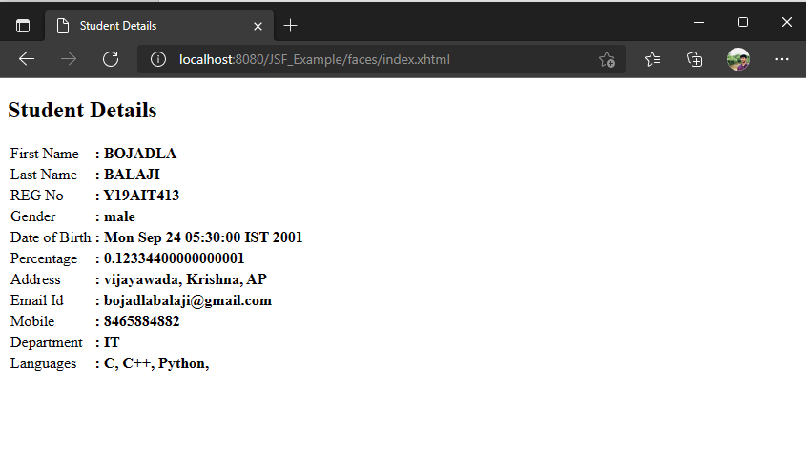

Experiment : 5
Aim: Create a web application to demonstrate JDBC and perform the following operations: Creation, Insertion, Updating, Display, Deletion.
Application File Structure:

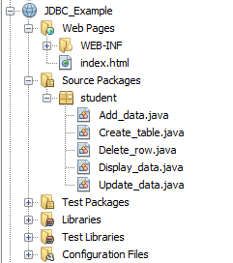

Source code:
index.html
<!DOCTYPE html>
<html>
<head>
<title>Details</title>
<style>
form{
float:left;
border:2px solid black;
padding: 20px;
margin:30px;
width:320px;
height: 200px;
}
</style>
</head>
<body>
<form action="Create_table" id="container" method="post" style="width: 745px">
<h2>Create New Table</h2>
Table Name :<input type="text" name="tablename" required /><br><br>
Column1 Name:<input type="text" name="col1" required />
Data Type:<input type="text" name="type1" required /><br>
Column2 Name:<input type="text" name="col2" />
Data Type:<input type="text" name="type2" /><br>
Primary Key:<input type="text" name="key" /><br><br>
<input type="submit" value="CREATE"/>
</form>
<form action="Add_data" method="post">
<h2>ADD New Data</h2>
Column 1 :<input type="text" name="name" required /><br><br>
Column 2 : <input type="text" name="reg" required/><br><br>
<input type="submit" value="Add"/>
</form>
<form action="Update_data" method="post">
<h2>Update Data</h2>
New Column 1 :<input type="text" name="newname" /><br><br>
primary key : <input type="text" name="reg" /><br><br>
<input type="submit" value="UPDATE">
</form>
<form action="Display_data">
<h2>Display Data</h2>
<input type="submit" value="DISPLAY">
</form>
<form action="Delete_row" method="post">
<h2>Delete Row</h2>
primary key : <input type="text" name="reg" /><br><br>
<input type="submit" value="DELETE">
</form>
</body>
</html>

Output:

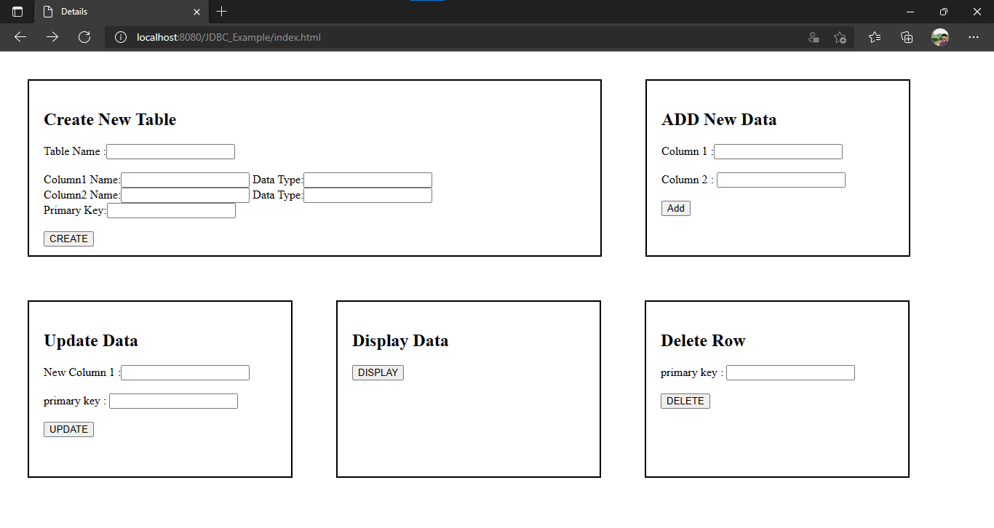

Create_table.java
package student;

import java.io.IOException;
import java.io.PrintWriter;
import java.sql.*;
import javax.servlet.ServletContext;
import javax.servlet.ServletException;
import javax.servlet.http.*;

public class Create_table extends HttpServlet {

protected void processRequest(HttpServletRequest request, HttpServletResponse response)
throws ServletException, IOException {
response.setContentType("text/html;charset=UTF-8");
PrintWriter out = response.getWriter();
try {
String name=request.getParameter("tablename");
String col1=request.getParameter("col1");
String type1=request.getParameter("type1");
String col2=request.getParameter("col2");
String type2=request.getParameter("type2");
String pkey=request.getParameter("key");
Class.forName("org.apache.derby.jdbc.ClientDriver");
Connection con = DriverManager.getConnection("jdbc:derby://localhost:1527/college", "student","student");
String sql="CREATE TABLE "+name+"("+col1+" "+type1+","+col2+" "+type2+",PRIMARY KEY ("+pkey+"))";
Statement ps=con.createStatement();
int result=ps.executeUpdate(sql);
ServletContext context=getServletContext();
context.setAttribute("tablename",name);
context.setAttribute("col1",col1);
context.setAttribute("col2",col2);
out.println("Table Created Successfully");
out.println("<br><a href='index.html'>Goto Index</a>");
out.println("</body>");
out.println("</html>");
ps.close();
con.close();
}catch(ClassNotFoundException | SQLException e){
out.println("Error: "+e);
}
}

Output:
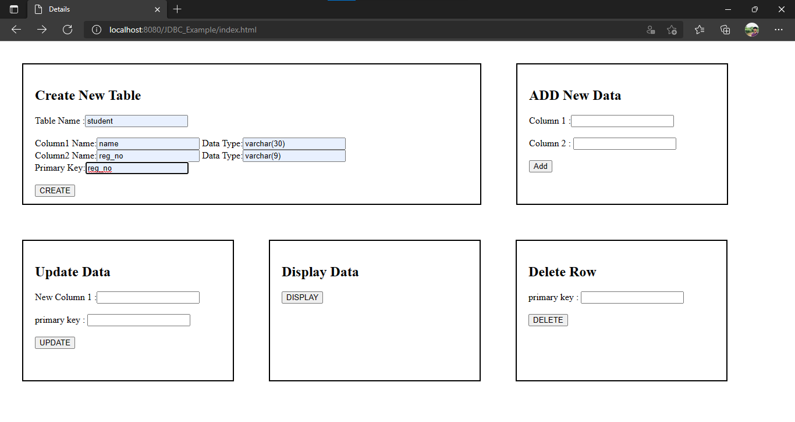
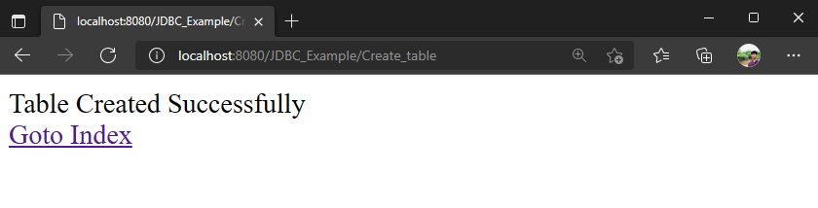
Database Structure:
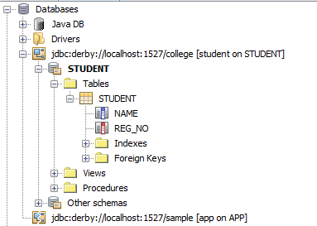

Add_data.java
package student;
import java.io.IOException;
import java.io.PrintWriter;
import java.sql.*;
import java.util.logging.*;
import javax.servlet.ServletContext;
import javax.servlet.ServletException;
import javax.servlet.http.*;

public class Add_data extends HttpServlet {
@Override
protected void doPost(HttpServletRequest request, HttpServletResponse response)

throws ServletException, IOException {
response.setContentType("text/html;charset=UTF-8");
PrintWriter out = response.getWriter();

String col1=request.getParameter("name");
String col2=request.getParameter("reg");
out.println("<title>Add_data</title>");
ServletContext context=getServletContext();
String table=(String)context.getAttribute("tablename");

try{
//dataSource class
Class.forName("org.apache.derby.jdbc.ClientDriver");
Connection con = DriverManager.getConnection("jdbc:derby://localhost:1527/college", "student","student");
String sql="insert into "+table+" values(?,?)";
PreparedStatement ps=con.prepareStatement(sql);
ps.setString(1, col1);
ps.setString(2, col2);

int result=ps.executeUpdate();

if(result>0)
out.println("Data Inserted Successfully");

else
out.println("Data Insertion Failed");

out.println("<br><a href='index.html'>Goto Index</a>");
ps.close();
con.close();
} catch (ClassNotFoundException | SQLException ex) {
Logger.getLogger(Add_data.class.getName()).log(Level.SEVERE, null, ex);
}

}
}

Output:

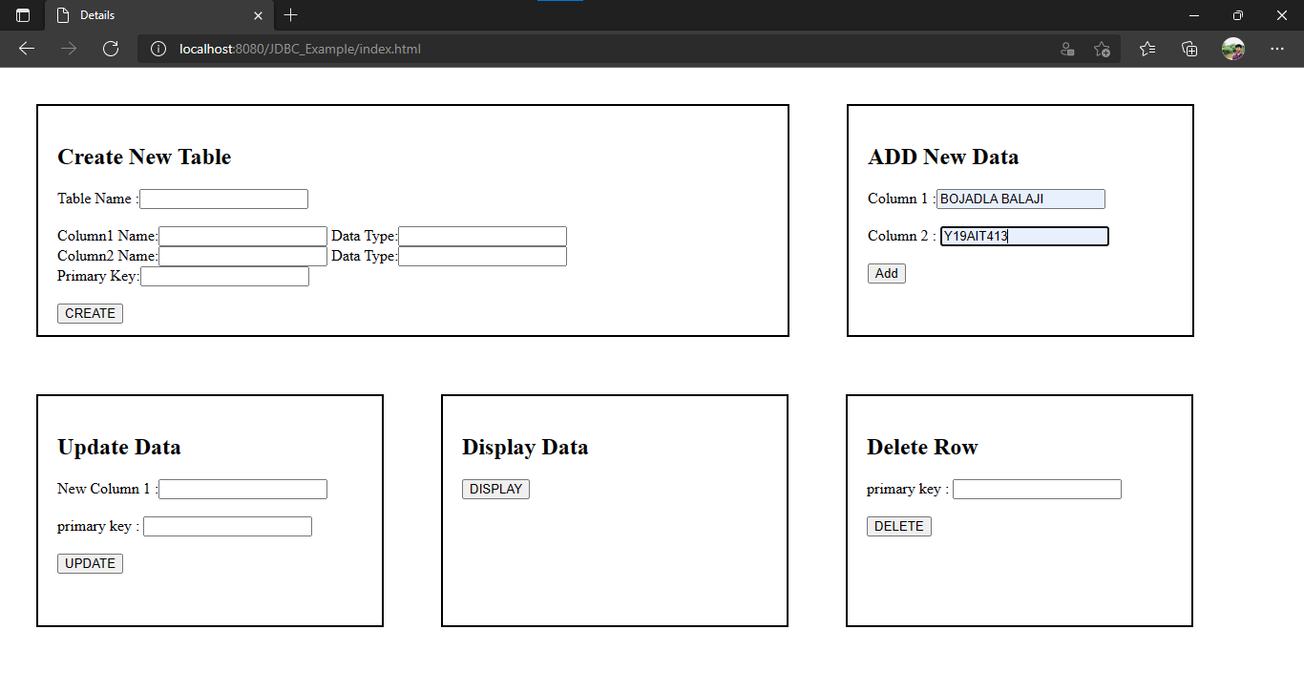

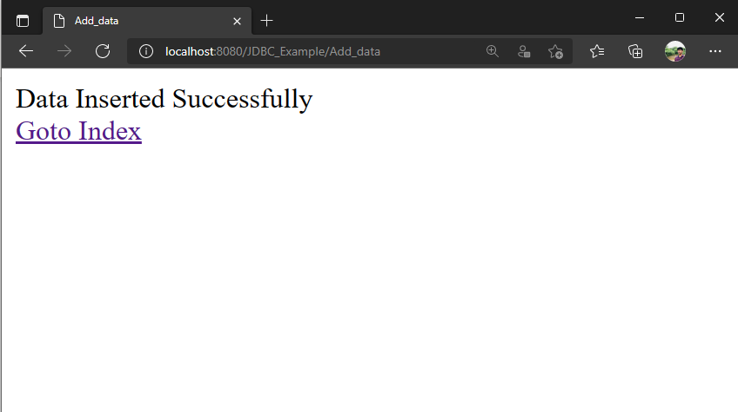

Display_data.java
package student;

import java.io.*;
import java.sql.*;
import java.util.logging.*;
import javax.servlet.ServletContext;
import javax.servlet.ServletException;
import javax.servlet.http.*;
public class Display_data extends HttpServlet {
@Override
protected void service(HttpServletRequest request, HttpServletResponse response)
throws ServletException, IOException {
response.setContentType("text/html;charset=UTF-8");
PrintWriter out = response.getWriter();
out.println("<title>Display_data</title>");
try{
Class.forName("org.apache.derby.jdbc.ClientDriver");
Connection con=DriverManager.getConnection("jdbc:derby://localhost:1527/college", "student","student");
java.sql.Statement s=con.createStatement();
ServletContext context=getServletContext();
String table=(String)context.getAttribute("tablename");
String col_1=(String)context.getAttribute("col1");
String col_2=(String)context.getAttribute("col2");
String sql="select * from "+table;
ResultSet rs=s.executeQuery(sql);
out.println("<h2>"+table.toUpperCase()+" Table:</h2>");
out.println("<table cellpadding=6 border=2>"
+ "<tr>"
+ "<th>"+col_1.toUpperCase()+"</th>"
+ "<th>"+col_2.toUpperCase()+"</th>"
+ "</tr>");

while(rs.next()){
out.println("<tr>");
out.println("<td>"+rs.getString(col_1)+"</td><td> "+rs.getString(col_2)+"</td></tr>");
}
out.println("</table>");
out.println("<br><a href='index.html'>Goto Index</a>");
s.close();
con.close();
} catch (ClassNotFoundException | SQLException ex) {
Logger.getLogger(Display_data.class.getName()).log(Level.SEVERE, null, ex);
}
}
}

Output:

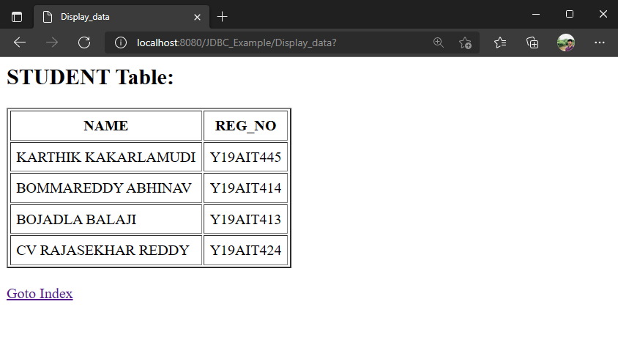

Update_data.java

package student;
import java.io.*;
import java.sql.*;
import javax.servlet.ServletContext;
import javax.servlet.ServletException;
import javax.servlet.http.*;

public class Update_data extends HttpServlet {

@Override
protected void doPost(HttpServletRequest request, HttpServletResponse response)
throws ServletException, IOException {
response.setContentType("text/html;charset=UTF-8");
PrintWriter out = response.getWriter();
try {
String name=request.getParameter("newname");
String reg=request.getParameter("reg");
ServletContext context=getServletContext();
String table=(String)context.getAttribute("tablename");
String col_1=(String)context.getAttribute("col1");
String col_2=(String)context.getAttribute("col2");
Class.forName("org.apache.derby.jdbc.ClientDriver");
Connection con = DriverManager.getConnection("jdbc:derby://localhost:1527/college", "student","student");

String sql="UPDATE "+table+" SET "+col_1+"=? WHERE "+col_2+"=?";
PreparedStatement ps=con.prepareStatement(sql);
ps.setString(1, name);
ps.setString(2, reg);
int result=ps.executeUpdate();
if(result>0){
out.println("Data Updated Successfully");
request.getRequestDispatcher("Display_data").include(request, response);
}
else{
out.println("Data Updated Failed");
out.println("<br><a href='index.html'>Goto Index</a>");
}
out.println("</body>");
out.println("</html>");
ps.close();
con.close();
}catch(ClassNotFoundException | SQLException e){
out.println("Error: "+e);
}
}
}
Output:

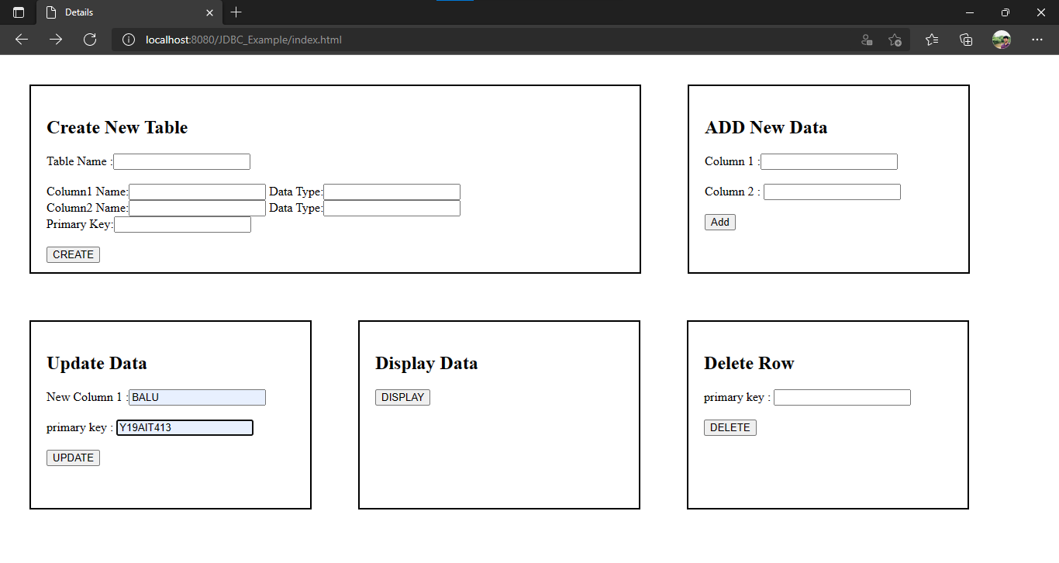

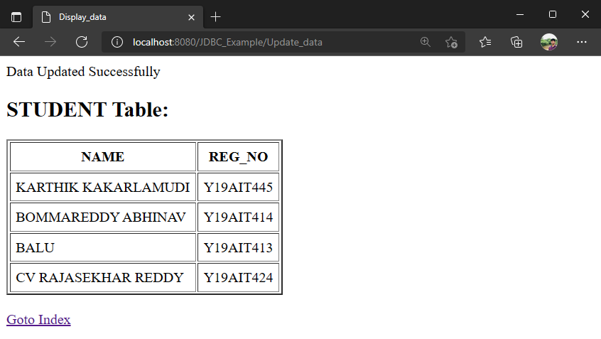

Delete_row.java

package student;
import java.io.IOException;
import java.io.PrintWriter;
import java.sql.*;
import java.sql.SQLException;
import javax.servlet.ServletContext;
import javax.servlet.ServletException;
import javax.servlet.http.*;

public class Delete_row extends HttpServlet {
@Override
protected void doPost(HttpServletRequest request, HttpServletResponse response)
throws ServletException, IOException {
response.setContentType("text/html;charset=UTF-8");
PrintWriter out = response.getWriter() ;
try {
String name=request.getParameter("newname");
String reg=request.getParameter("reg");
ServletContext context=getServletContext();
String table=(String)context.getAttribute("tablename");
String col_1=(String)context.getAttribute("col1");
String col_2=(String)context.getAttribute("col2");
Class.forName("org.apache.derby.jdbc.ClientDriver");
Connection con = DriverManager.getConnection("jdbc:derby://localhost:1527/college", "student","student");
String sql="DELETE FROM "+table+" WHERE "+col_2+"=?";
PreparedStatement ps=con.prepareStatement(sql);
ps.setString(1, reg);
int result=ps.executeUpdate();
if(result>0){
out.println("Data Deleted Successfully");
request.getRequestDispatcher("Display_data").include(request, response);
}
else{
out.println("Data Deleted Failed");
out.println("<br><a href='index.html'>Goto Index</a>");
}
out.println("</body>");
out.println("</html>");
ps.close();
con.close();
}catch(ClassNotFoundException | SQLException e){
out.println("Error: "+e);
}
}
}

Output:

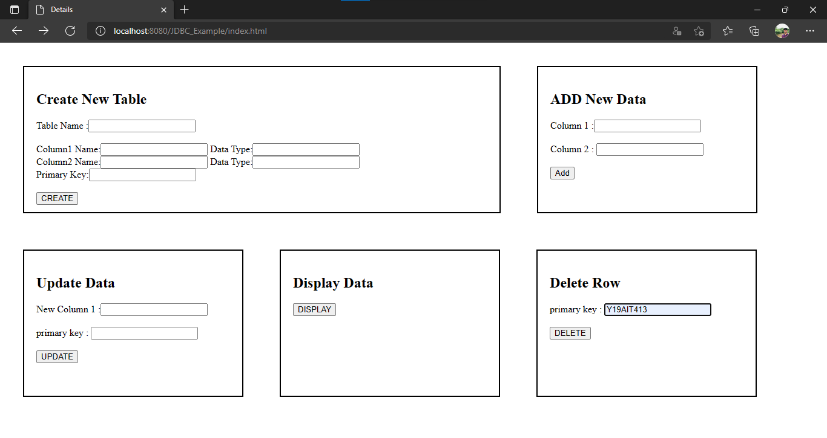

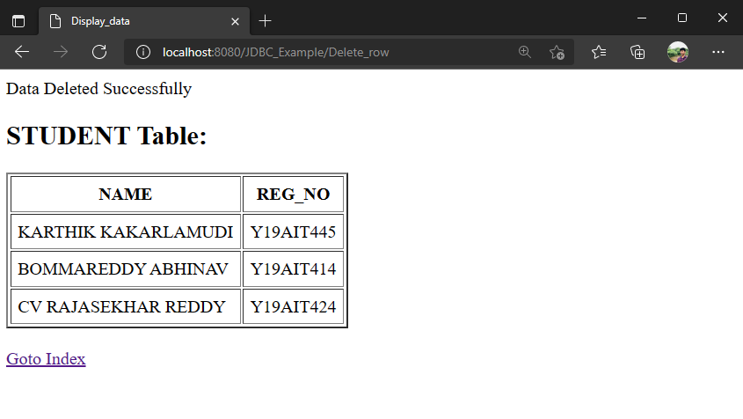
Experiment : 6
Aim: Create a Java EE application to demonstrate Stateless Session Bean.
Application File Structure:

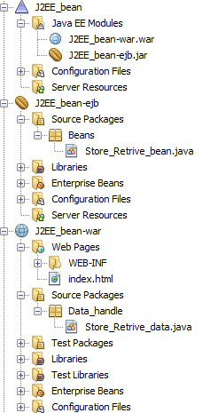

Source code:
index.html
<!DOCTYPE html>
<html>
<head>
<title>Registration Form</title>
<meta charset="UTF-8">
<meta name="viewport" content="width=device-width, initial-scale=1.0">
</head>
<body>
<div>
<h1>Student Registration Form</h1>
<form action="Store_Retrive_data" method="post">
<table>
<tr>
<td>Name</td>
<td><input type="text" name="name"></td>
</tr>
<tr>
<td >Reg no.</td>
<td><input type="text" name="reg"></td>
</tr>
<tr>
<td >Gender</td>
<td><input type="radio" name="gender" value="Male">Male
<input type="radio" value="Female" name="gender">Female
</td>
</tr>
<tr>
<td > Academic Year</td>
<td><input list="year" name="year"></td>
<datalist id="year">
<option value="2018-2019">
<option value="2019-2020">
<option value="2020-2021">
</datalist>
</tr>
<tr>
<td >Branch</td>
<td><input type="text" list="Branch" name="branch"></td>

<datalist >
<option value="CSE">
<option value="IT">
<option value="ECE">
<option value="EEE">
<option value="Civil">
<option value="Mechanical">
<option value="E&I">
<option value="Data Science">
<option value="Cyber Security">
</datalist>
</tr>
<tr>
<td >Year Of Study</td>
<td><input list="yos" name="yos" ></td>
<datalist id="yos">
<option value="I Year ">
<option value="II Year">
<option value="III Year">
<option value="IV Year">
</datalist>
</tr>
<tr>
<td >Course</td>
<td><input list="course" name="course" ></td>
<datalist id="course">
<option value="B.TECH."></option>
<option value="M.TECH."></option>
<option value="M.SC."></option>
<option value="MCA"></option>
<option value="DIPLOMA"></option>
</datalist>
</tr>
<tr>
<td >Languages</td>
<td>
<input type="checkbox" name="langs" value="python">
<label for="python" > Pyton&nbsp;</label>
<input type="checkbox" name="langs" value="c">
<label for="c" >C</label><br>
<input type="checkbox" name="langs" value="java">
<label for="java" > Java &nbsp;&nbsp;</label>
<input type="checkbox" name="langs" value="c++">
<label for="c++" >C++</label>
</td>
</tr>
<tr>
<td><input type="submit" value="Submit"></td>
<td><input type="reset" value="Reset"></td>
</tr>
</table>
</form>
</div>
</body>
</html>

Output:

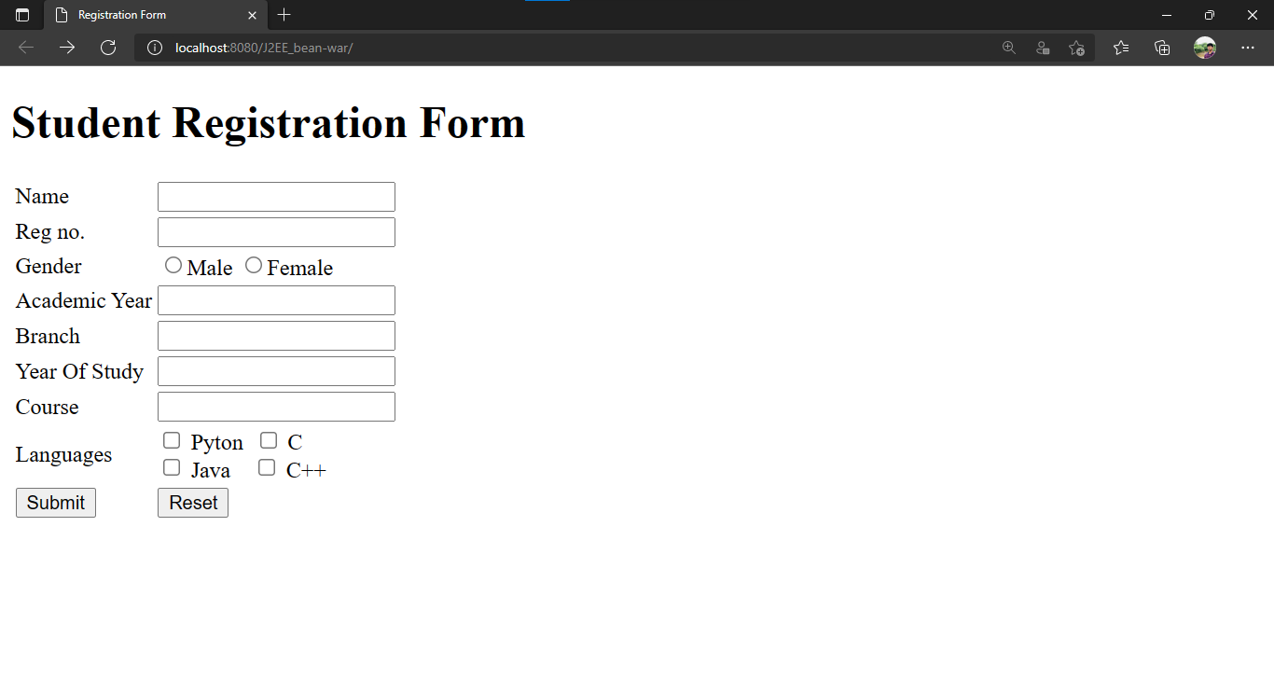

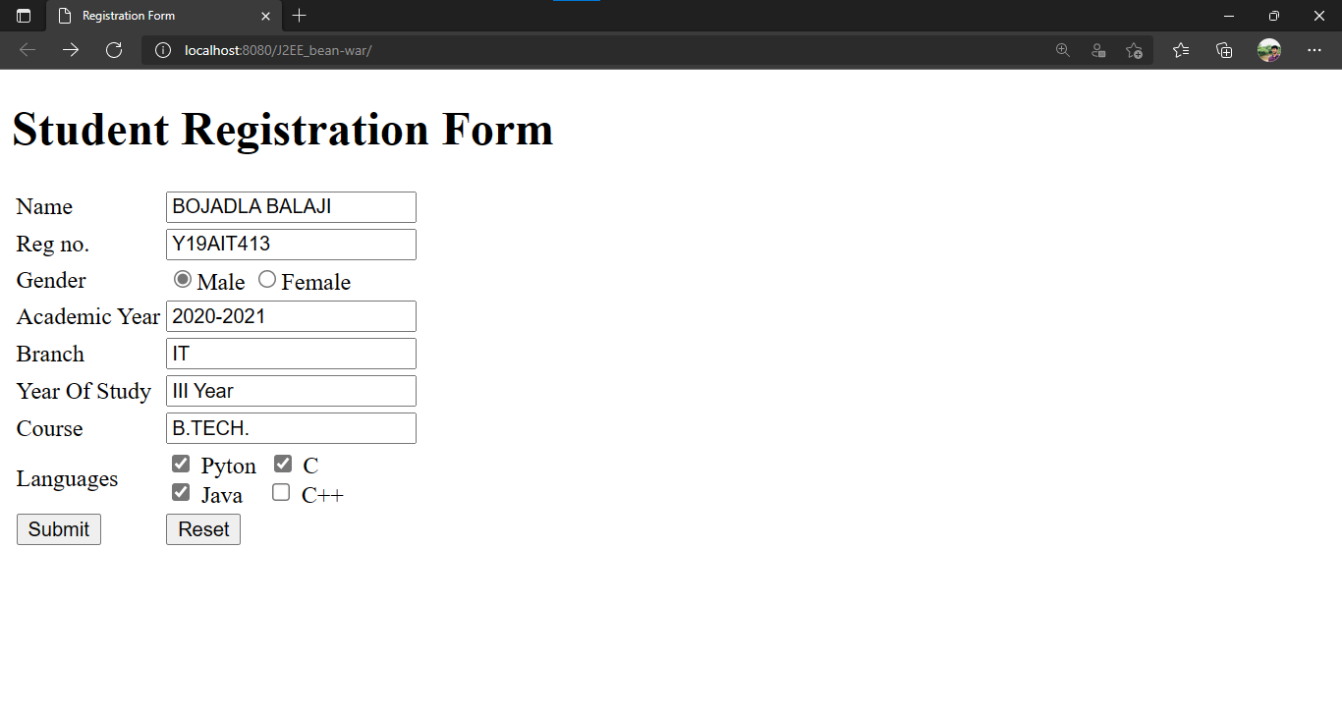

Store_Retrive_bean.java

package Beans;

import javax.ejb.Stateless;
import javax.ejb.LocalBean;

@Stateless
@LocalBean
public class Store_Retrive_bean {

private String name,reg,gender,a_year,yos,branch,course;
private String langs[];

public String getName() {
return name;
}

public void setName(String name) {
this.name = name;
}

public String getReg() {
return reg;
}

public void setReg(String reg) {
this.reg = reg;
}

public String getGender() {
return gender;
}

public void setGender(String gender) {
this.gender = gender;
}

public String getA_year() {
return a_year;
}

public void setA_year(String a_year) {
this.a_year = a_year;
}

public String getYos() {
return yos;
}

public void setYos(String yos) {
this.yos = yos;
}

public String getBranch() {
return branch;
}

public void setBranch(String branch) {
this.branch = branch;
}

public String getCourse() {
return course;
}

public void setCourse(String course) {
this.course = course;
}

public String[] getLangs() {
return langs;
}

public void setLangs(String[] langs) {
this.langs = langs;
}

}

Store_Retrive_data.java

package Data_handle;

import Beans.Store_Retrive_bean;
import java.io.IOException;
import java.io.PrintWriter;
import javax.ejb.EJB;
import javax.servlet.ServletException;
import javax.servlet.http.HttpServlet;
import javax.servlet.http.HttpServletRequest;
import javax.servlet.http.HttpServletResponse;

public class Store_Retrive_data extends HttpServlet {

@EJB
Store_Retrive_bean srb;

@Override
protected void doPost(HttpServletRequest request, HttpServletResponse response)
throws ServletException, IOException {
response.setContentType("text/html;charset=UTF-8");
try (PrintWriter out = response.getWriter()) {

String name=request.getParameter("name");
String reg=request.getParameter("reg");
String gender=request.getParameter("gender");
String a_year=request.getParameter("year");
String yos=request.getParameter("yos");
String branch=request.getParameter("branch");
String course=request.getParameter("course");
String[] langs=request.getParameterValues("langs");

out.println("<!DOCTYPE html>");
out.println("<html>");
out.println("<head>");
out.println("<title>Store_Retrive_data</title>");
out.println("</head>"
+ "<style>"
+ "body{"
+ "background-color:pink;"
+ "}"
+ "</style>");
out.println("<body>");
out.println("<h1>Student Details</h1>");
srb.setName(name);
srb.setReg(reg);
srb.setGender(gender);
srb.setBranch(branch);
srb.setA_year(a_year);
srb.setYos(yos);
srb.setLangs(langs);
srb.setCourse(course);

out.println( "<h3>Name : "+srb.getName()+"<br>"
+ "Register Number : "+srb.getReg()+"<br>"
+ "Gender : "+srb.getGender()+"<br>"
+ "Academic Year : "+srb.getA_year()+"<br>"
+ "Branch : "+srb.getBranch()+"<br>"
+ "Year of Study : "+srb.getYos()+"<br>"
+ "Course : "+srb.getCourse()+"<br>"
+ "Languages : ");
for(String l: srb.getLangs()){
out.println(l+",");
}

out.println("</h3></body>");
out.println("</html>");
}
}

}

Output:

